
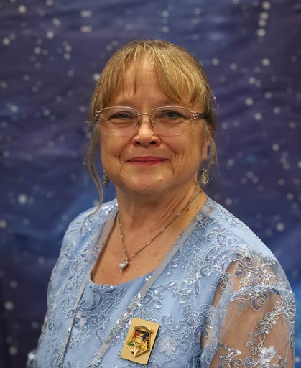

Palmetto Star News
N
A
O
R
D
E
R
o
f
t
h
e
E
A
T
E
R
o
f
S
O
U
T
H
C
A
R
O
L
I

Volume 67 October 2026 Issue 10
S
T
E
R
N
S
T
A
R
G
R
A
N
D
C
H
A
P

News from the Worthy Grand Matron 
Hello Sisters and Brothers I hope you have had as much fun as I have this month. It has been very busy. On August 1 we had Popeye School of Instruction #4, at Dixon chapter. The district that hosted were #1-6-9.
Everything was ready for us the school went well. We had 84 members attend this school. I am very happy with the participation this year.
On August 6 there was a Charitable Giving Presentation to Operation Patriots FOB (Forward Operating Base). Sponsored by Lillie Chapter. Those present Don Cool PGP, Grand Lecturer to present the check. Sister Durena Marcum, Jennifer Bailey Gr. Conductress, Judy Boykin Gr.
Martha, Milly Cool. Their mission is to help first responders, Active duty, and veterans and family members who suffer from PTSD.
August 7 - We travel down to Charleston to One 80. Sponsored by Loyalty Chapter. Their mission is finding a solution for the unhoused, and to provide food, lodging and safety. They have several areas in Charleston where they can attend people from those area. It is a fantastic facility and a lot of the needs are met daily. Those present myself, Mike Smith WGP, Kaye Rackley PGM Gr.
Treasurer, Fred and Anna Armstrong, Josiane Horton Gr Trustee, Lynette Jenkins Gr Trustee, Don Owens Gr. Sentinel, Angie Owens, Mr. and Mrs. Susan Brady, Valerie Weeks, Beth Gibbs.
August 8 - Milkyway School of Instruction #5 at CCMA Districts 13-15. Great school. We had 81 members in attendance. However the districts out did themselves with that dessert table WOW. No one walked away hungry. Such a great day with my sisters and brothers. We also announced the Grand Trip which I will tell you about at the end.
August 12 - Another Charitable giving presentation was given to Hope Mission of the Upstate in Anderson. Sponsored by Anderson. They serve breakfast 6 days a week to anyone with warm coffee available, and warm conversations as well, they also provide some medical help when needed and opens their doors as a warming center in the winter when the temperature drops so they have some place to go. There is a picture of the presentation in this new paper.
August 14 - We traveled to Spartanberg in the morning to P.S. I Love you sponsored by Roebuck Chapter. This charity supports the needs of Foster Children and the Family’s who care for them. They provide clothes, personal needs and give them a feeling of self worth during the most difficult time in their short lives. Great operation, very organized. Those present were myself, Mike Smith WGP, Anita Dixon AGM, Mark O’Shield AGP, Kaye Rackley PGM, Gr. Treasurer, Lynette Jenkins Gr. Trustee, Josiane Horton Gr. Trustee, Kim DesRosiers AGC, Ann and Randy McKendrick, Linda Hoover, Barbara Sanford, Julie Bowker.

After a great lunch we made our way over to Greenville for another Great Charitable Giving Presentation to Service Dogs For Veterans, sponsored by Dentsville Chapter. Here the service dog and the veteran trains together and build a bond and rely on each other. It helps the veteran to cope with day to day activity. And the dog helps the veteran when the nightmares and, loneliness and bad memories return.
Those present for the check presentation were. Myself, Mike Smith WGP, Anita Dixon AGM, Kaye Rackley, PGM Gr. Treasurer, Kim Desrosiers AGC, Fred Armstrong PGP, Ch. Gr. Trustee, Lynette Jenkins Gr. Trustee, Josiane Horton, Gr. Trustee, Julie Bowker. There were 4 Veterans with their partners. They gave us a demonstration. It was a great day all around.
August 21 - We travelled down to Aiken for a presentation to The Children’s Place Inc. Sponsored by Golden Glow Chapter. Their mission is to protect, heal and strengthen children from the impacts of trauma in their lives. This Charity serves 5 counties. Through education, mental and physical treatments and prevention services. Helping, loving, and caring for their needs. Those present were myself, Kaye Rackley PGM Gr. Treasurer, Lynette Jenkins Gr. Trustee, Judy Justice, Robert Justice, Debbie Kenny, Christen Greenway, Jeff Greenway, Maggie Kilby.
August 22 - The Grand Officers were asked to perform an initiation for 9 members of Lyman Chapter and 3 members for Greer Chapter. We were so proud to do it. And now we have 12 new sisters and brothers. We performed the ceremony twice with 6 members each. And after it was over we all enjoyed a great lunch provided by the Chapters. It was an Epic day. We had 64 members present some from the chapters who gained new members, the Grand Officers. And members from around the state to witness event. So Proud.
August 28 - We travelled to Myrtle Beach. To the Helping Hands of Myrtle Beach Inc. Sponsored by Myrtle Beach #180. The mission of this charity is to support basic needs of the community to provide and assist with rent, utilities, transportation and provide 5 days worth of emergency food to fill a short term need.
August 29 - North Star School of instruction #6 District 20 @ Loris chapter. This is the last school of the year. We had 64 members attend this school. Bro Don Cool, PGP Grand Lecturer has led us and schooled us all summer long. Our officers and Deputy Grand Marshall’s did a super job for this school and We were honored to let them shine. District 20 and sister Debra Caesar did a beautiful job hosting they were great at remembering to recycle, reuse and repurpose, all things. My thanks to that great effort.
After we finished the school the grand officers honored our Grand Lecturer with a roast of all we had learned from him. Brother Don Cool, PGP I want to thank him for his dedication to this task. Each week was different, and he adjusted to the changing sencerios . I am so happy you agreed to be our Grand lecturer.

As August comes to an end. I look for ward to September. We will be starting our official vistis. Our inspecting Grand Officers are so excited to come and visit you and get to know each and every one of you.

We shall see you on the road very soon. May God Bless on your travels.
Remember to show G.R.A.C.E. Grand Respect and Compassion to Everyone. We cannot possible know what someone that is close to us is going through. But if we give GRACE and understanding without judgement, there is love behind our reasons. May God Bless you and yours.
Judy M. Krummich WGM
Mike and I have decided about the Grand Trip. It is the SC O.E.S. Looking for the Fountain of Youth. We are going to Amelia Island, St. Augustine, and Jacksonville. We have flyers and reservations are being handled by Barbara Collins. March 1-4 2027 . There will be a Bus to take us there and a lot of laughter and great memories along the way. See Flyer for this event. And contact Barbara Collins with your reservations.



Grand Representatives

Dot Rivers Florida
Carolyn Bradford Missouri

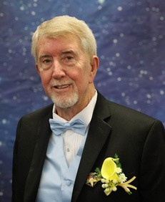


News from the Worthy Grand Patron

Greetings to all my sisters and brothers. Schools are finished and Official Visits have started. We had the first one at Talulah Chapter in Spartanburg on September 4, and it was a good start to the OV’s. Parking was a bit of a challenge, but everyone managed to find a place and made inside for a
great meeting. You have just read all the information on the completion of the schools and the check presentations from the WGM, and I will add how much I enjoyed traveling to make these presentations and see the work they do. Speaking of the schools. A big shout out goes to Bro Don Cool, PGP for all the work he put into them to make it a success. Thank you Don. Check your itinerary to see what is happening when and where, and come join us on the road. If you don’t have one, see your DD and they will get you one. Our tr[ip to Jacksonville and St.


Augustine is coming along great. We have 1 full bus already and a waiting list for another bus. I was told Sunday, Sept 20 we needed 14 to get another bus. This is looking to be a great trip, so get signed up and join us on this trip. There is a flyer attached with the information. Be safe on the road and in your travels.
Mike Smith WGP

Motorcoach transpol'tatilon
3 nights lodg'lng In the .l•acksonvllle area
- 6 meals: 3 breakfasis and 3 dinners
- Guided Tour of .Amelia Island, Florida
- Viaii to Femandina Beach Historical District, with stroll alo119
ti.a.ch
- Guldad Trolley Tour of St. Augustin■., followed by Hop-Onllitop-Off Ptlvllages
- Visit to Historic St. Geor,ge Sir,eei
- N■Tll'.lllted Cn.iit• on the St. John's River
- Din"-" Pi!11rty ·with ll!nt•rt11inm•nt
- Admlulon to·th• St. Augustin• History Mu.aeum

$550*

Departure: Columbia, SC @ 8 am
Day 1: Board your spadous, video and restroom equipped Mo,torcoach and set off for the sunshine of Jac:ks.onviille, FIlorida! Upon arrival, you'll enjoy Dinner and check into your Jacksonviill!e area hotel for a three n.ight stay.
Day 2: After a Continental Breakfast, enjoy a scenic dnive along the coast accompanied by your
guide. Learn about the Kingsl!ey pllantatfon and Fllorida'sunusual history as you head to AMELIA ISLAND, southernmost of1he Atlantiic coast barriier islands. After taking a GUIDE.D TOUR ofth1is beautiful island, you'll viisit the historical district in Fernandina Beach and have an opportunity to stroll along thisstunniing beach. This evening, enjoy a Dinne•r Party with Entertainment.
Day 3: Today, after enjoying a Continental Breakfast, your journey begins wiith a GUIIDEO,TROLI.EY
TOUR OF ST. AUGUSTIINE1 which offers a fascinating glimpse irnto the city's paist and its stunning architectura.l marvels.. The tour also iincludes admissiion to the St. Augustirne History Museum, pro,viding further insight into this histo,ric location. Following the 90�minuteTROLLEY tour, enjoy the flexibiliit,yof Hop-On/lHop-Off prh,He,ges om the TR:OLILEYfoir the rest ofthe day, allowing you to explore all of St. Aug1ustine at your own p,ace. Vou can choose to stop at numerous hi.stork landmarks including, but not limited to, the Old Jail, Potters Wax Museum, City Gates, St.George Street, Churches, Lightner Museum, St. Au,gustine Distillery, San Sebastian Winery, Plaza de Ila Consm.ucion, The Oldest House, The Marina, Riple•y'sBelieve It Or Not, and the Fountain of Youth. (Please note the admissfon to these additional museums and attractions along the trolley route is on your own.) Tonight, you'll relax and enjoy Dinner at a local area restaurant.
Day 4: After enjoyi1n19 a Contin,e1ni1:al B1reakfast, you'll depart for a.NARRATED CRUISE o,n the ST.. JOHN'SRIVER. later, you'll depart for home... a perfect time to chat wiith yom friends about alll the fun things you've done, the great sights you've seen and where your next group trip will take you!

ADD SOME PEACE or MIND 10 YOH TRIP...
With Diamond Tours llduiive J'rave/Confiden Protection Plan.
See separate ad:Vertisement...
$75 Due Upon Signing. *Pri< per person,bas: don
double occupancy.Add $1S5forsingleo11:cupancy.
Final Payment Due:12/25/21026



FOR INF01RMATION & RESERVATIONS CONTACT:

Barbara Collins@ (843) 100..5147
Mot,orcoachDriver and Step-on Guide gratuities indu:dedlin flyer price,
Form ID: 500-4A0306 WM 'Tour#:2308585


ITINERARY CHANGES
Official Visit of Newberry Chapter has been rescheduled to November 7, 2026. Official Visit of Azalea Chapter #192 has been rescheduled to January 23, 2027. Official Visit of Lillie Chapter #27 has been rescheduled to February 15, 2027.

Lillie Chapter #27 has changed their meeting time - new time is 6:15 p.m. for dinner and 7 p.m. for meeting. We will still meet on the 3rd Monday.

Newberry Chapter #226 Grand Organist has been moved to Nov. 7

Seneca #5
Seneca #5 had their regular stated meeting on September 15, 2026. We enjoyed a delicious meal and wonderful fellowship. We have been busy this year. We have supported First Light, Foothills assisted living, service dogs, Bennett, the Seneca police department and the Richard Campbell veterans home. I'm so proud of my chapter and it's accomplishments. The members of this chapter have really stepped up to the plate. I appreciate and love them all. Well the schools are over and the official visits have begun. Let's all get out there and visit as many chapters as possible. They need our support.
We are raffling off a beautiful throw that sister Dallas made and donated. The tickets are $10 each and the drawing will be at our January meeting. The throw is beautiful and it's a American flag. We are also selling the COFFEE shirts. If anyone would like one, contact me or sister Vickie Graham.
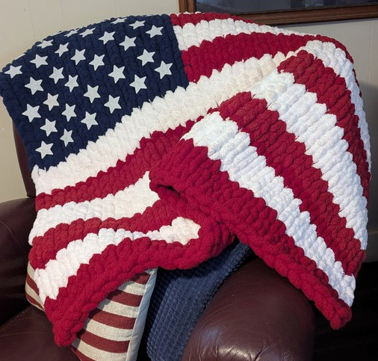
Please keep praying for our country and we have so many sick throughout the state. Safe travels to all and God bless you.
Star love, Patty Alger PSN reporter


Carolina 25
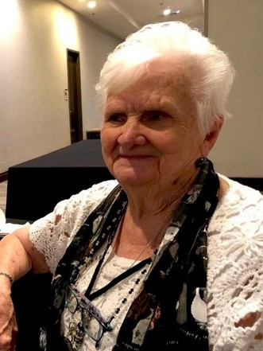
Hi Everyone, hope your summer break was a good one. We here in the 15 District are coming back, after being in the dark for 2 months. It was a busy two months though. We were going to Schools of Instruction, helping prepare and serving, at our school of instruction and visiting other chapters. Plus getting some things completed, around the chapter that needed to be done.
We would like to invite your Official Visit, October 26, 2026, 6:00 PM, Highway 165, Ravenel, SC. On November 23, 2026 we have a special celebration that evening, for our Worthy Matron, sister Erma Burke, for her over 54 years, of service, in the O.E.S. and 92nd birthday. Please let Carolyn Snelson know (email clsnelson44gmail.com) if you plan to attend so we may be prepared. If you can’t attend, you may send cards, etc to me at 9345 Blue House Road, Apt 10102, Ladson, SC 29456.
We are looking forward to a great time, in the months to come. We would love to see and fellowship with each of you. The Welcome Mat is always out, and the light is on. So come on down and spend an evening with us!!!!
Carolyn Snelson, PSN Carolina #25 May God bless each of you and give safe travels ♥

PAGO Reminder
Reminder to all PAGOs (Past Appointed Grand Officers) and their guests.
We will meet this Sunday, October 4, 2026, at 3 p.m. at Grecian Gardens Restaurant.
Address: 2312 Sunset Blvd, West Columbia, SC 29169.
Phone number to restaurant (803) 794-7552. Please join us for fellowship and great food!
If you haven't paid your dues for the 2026-2027 you may do so at this meeting. We will begin making plans for our luncheon at the "Looking to the Stars" 2026-2027 Grand Chapter Session.
Star Love, Dawn Blizard, Club Secretary

In Memoriam
Please keep the family and friends of the following Stars in your prayers: Gene Brown, Lexington 176
Bill Schneider, Golden Glow


OFFICIAL VISIT
You're Invited!
You're Invited!
Loris Chapter Monday, October 12, 2026 Mrs. Judy Krummich, WGM
Mr. Mike Smith, WGP Meal at 6 p.m.
Deborah Hartleroad, WM Franklin Strickland, WP

OFFICIAL VISIT
You're Invited!
Berkeley Chapter #112
Saturday October 17, 2026
Berkeley Masonic Lodge 301 California Ave., Moncks Corner, SC 29461
Inspecting Officer Mrs. Judy Krummich, WGM
Brother Mike Smith, WGP Banquet at 12 p.m.
Courtesy, Photos and Meeting to follow
Nancy Svagerko, Dist. Deputy, Dist. 18 Barbara Collins DGM to DD

OFFICIAL VISIT
Anderson Chapter #130
Tuesday, October 13, 2026 Hiram Masonic Lodge
118 E. Benson St., Anderson, SC 29624
Inspecting Officer Mrs. Judy Krummich, WGM
Mr. Mike Smith, WGP Mrs. Tammy Rigsby, WM
Mr. Mike Smith, WGP, WP, PT
Meal @ 6:00 p.m.
Courtesies @ 6:45 p.m. Pictures @ 7:00 p.m.
Prayer Circle @ 7:15 p.m.
Meeting @ 7:30 p.m.
You're Invited!

OFFICIAL VISIT
Roebuck Chapter #216
Monday, October 19, 2026
At Roebuck Masonic Lodge 4001 S Church St. Ext.
Roebuck, SC 29376
Inspecting Officer Mrs. Judy Krummich, WGM
Joining her is Mr. Mike Smith, WGP Mrs. Linda Hoover, WM
Mr. RandyMcKendrick, WP
Meal @ 6:00 p.m. Pictures @ 7:00 p.m.
Prayer Circle @ 7:15 p.m.
Meeting @ 7:30 p.m.

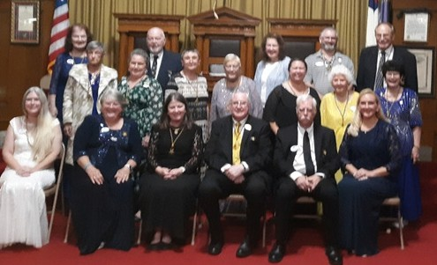
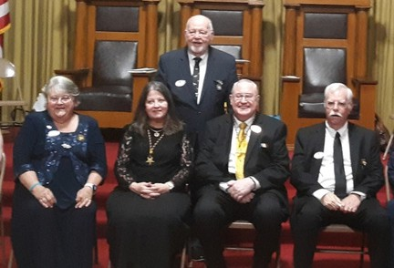
Talullah 16
We were honored to have AWM Anita Dixon as Inspecting Officer and AGP Mark O'Shields her escorts for Talullah 16 Official Visit on September 4.
Our banquet was delicious and enjoyed by our distinguished Grand Officers and visitors @ 6
p.m. Our meeting opened in long ritualistic form to a full house-appx. 38 members. We were also honored to have our WGM Judy Krummich and our WGP Mike Smith! They presented the Rob Morris Award to Elke Lester, Pat Alloy, Barbara Sanford and Sarah King.
WM Elke Lester presented our WGM and WGP and AGM Honorary Membership to Talullah 16. Sister Anita Dixon, AGM, presented certificate to WM for our Official Visit - she was very pleased with our efforts and hard work!
WE LOOK FORWARD TO OUR VISITORS EACH MONTH AT TALLULAH 16! STAR LOVE❤⭐❤⭐
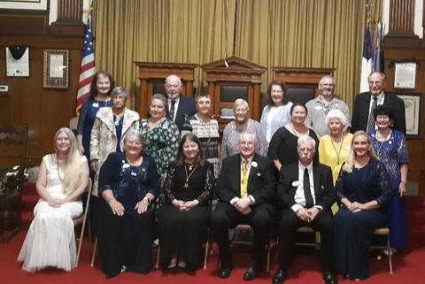
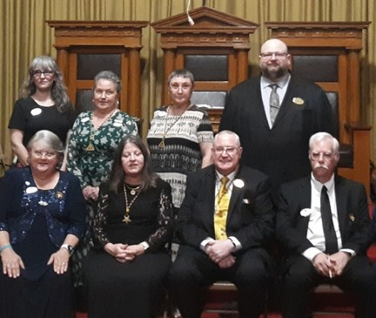
Barbara Sanford, Secretary

Mary Pinckney Outz 1
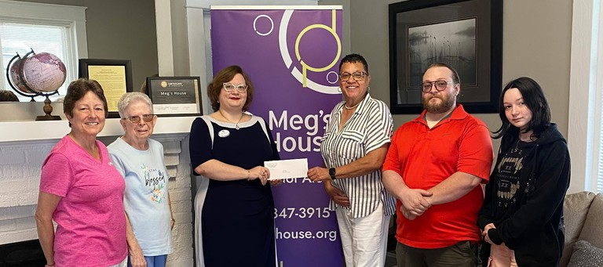
Mary Pinckney Ouzts #1 delivered Grand Chapter's $4,000 Charitable Giving donation to Meg's House on August 10, 2026. We were honored to speak with executive director Alicia Hodges about the impact Meg's House has on our community and how much we appreciate the important work they do for survivors of
domestic violence.

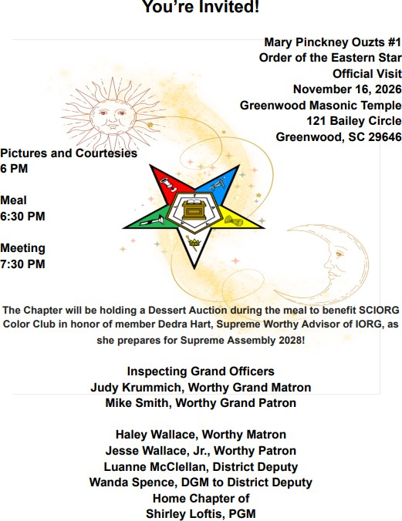
This year, Haley Wallace has selected Beyond Abuse for her special project as Worthy Matron. Beyond Abuse works to assist children facing abuse in receiving emergent care, legal aid, therapy services, and more. As of our September meeting, we have been able to collect and donate the following totals of essential supplies: 38 shirts, 17 rolls of paper towels, 44 rolls of toilet tissue, 200 13 gallon trash bags, 186 30 gallon trash bags, 12 boxes of Kleenex, 11 bottles of hand soap, 8 containers of disinfecting wipes, 6 bottles of hand sanitizer, 18 pairs of sweatpants, and 16 sweatshirts!

Charitable Giving Presentation
On Wednesday, September 2, 2026, Clover Chapter #138 had the honor to present to our nominated charity “Bethel Shelters” a check for $4,000.00 on behalf of Grand Chapter of SC. Bethel Shelters was most appreciative to have been chosen. We were given a tour of the facilities and information about what they do and why they do it. They just want to help those in need.
They told us about some of their success stories and how it changed their lives, and how some of them have come back to volunteer their time and have become donors to the Shelter.
Bethel Shelters is at Bethel United Methodist Church and has been in operation since 2009, and is the only emergency shelter in York, Chester, and Lancaster counties. They operate a community day shelter that offers services such as shower and restroom facilities and laundry services. They also provide on-site social services to help with housing, education, and have a workforce development program.
They also operate 36 bed men’s night shelter that offers shower and restroom facilities, emergency clothing, hygiene products, a meal is served each night, sponsored by various groups and businesses, as well as on-site case workers. They also have another 60+ cots for overflow that can be used at other churches in the area. They feed anywhere from 50-100 on any given day, with the winter months seeing the greatest need.
They do amazing work and we are proud that we could help with this monetary gift. If you would like to know more about them or would like to donate, go to their website: bethelshelters.org or follow them on Facebook.
Kathy Wallace, Clover Chapter 138
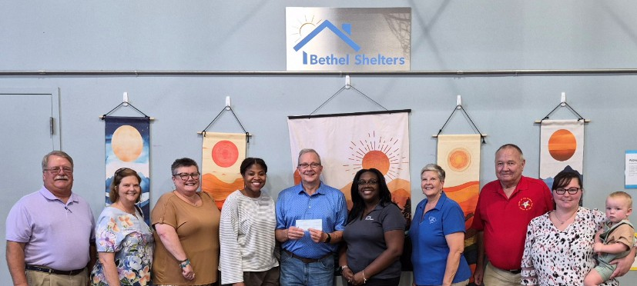
L-R: Steve Jackson, Jr. PGP, Sheila Jackson, Jr. PGM, Kim Desrosiers, AGC, Brooke Leaverett, Program Director, Richard Murr, Operations Director, Alicia Cohen, Executive Director, Kathy Wallace, Clover Chapter, David Wallace, Clover Chapter, Samantha Griffith & Rowen, Clover Chapter

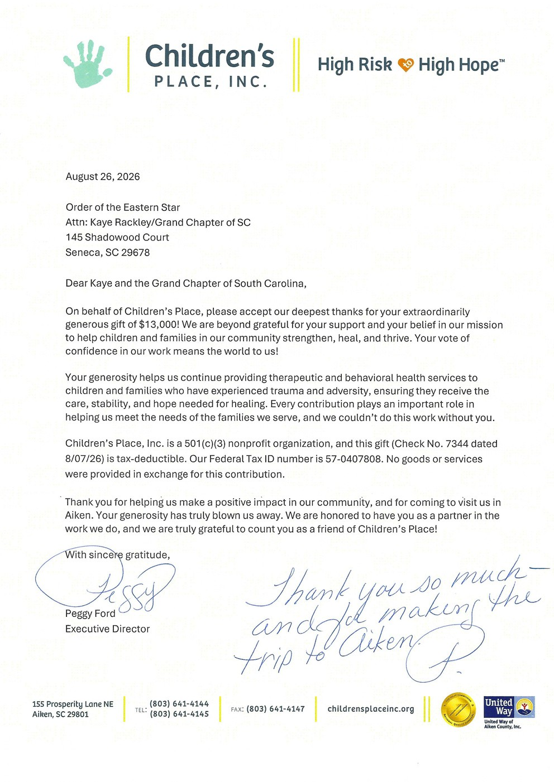
Volume 67 October 2026 Issue 10 Page 11

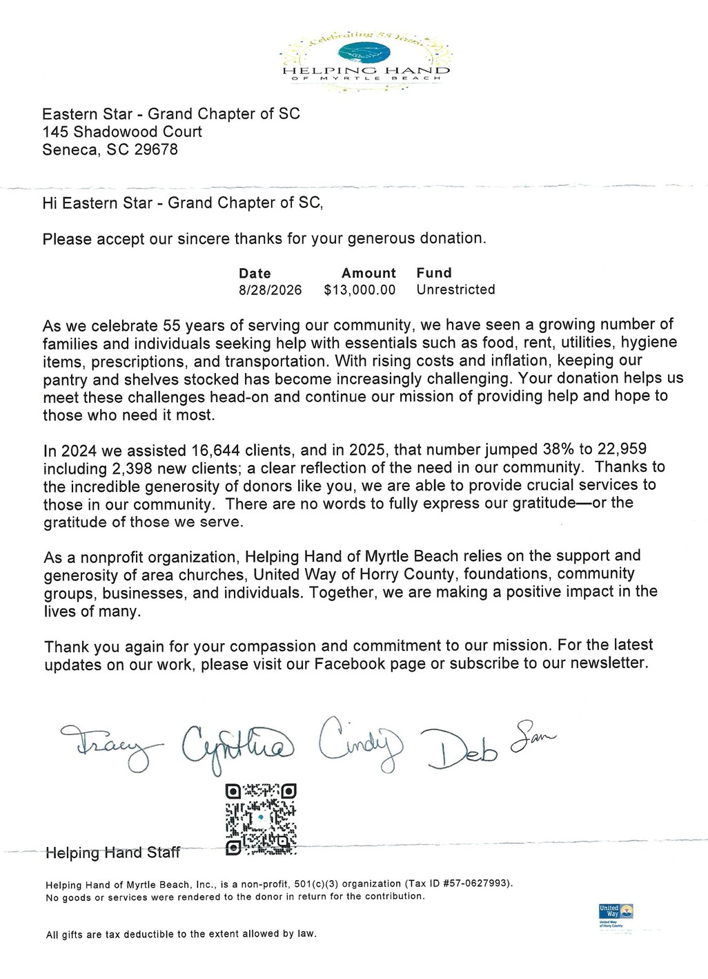
Volume 67 October 2026 Issue 10 Page 12

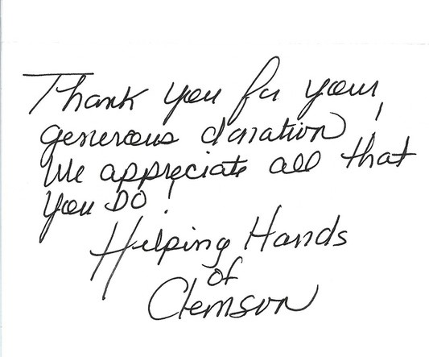
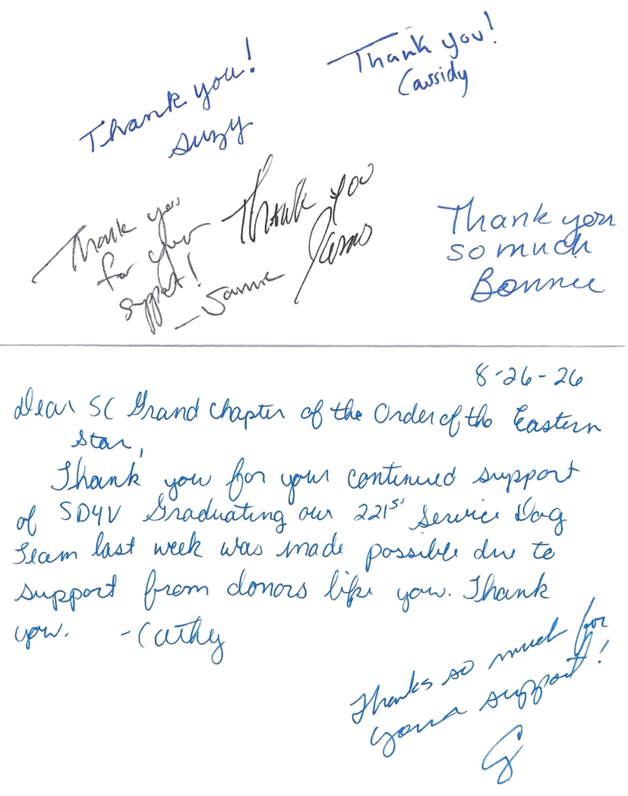
Volume 67 October 2026 Issue 10 Page 12

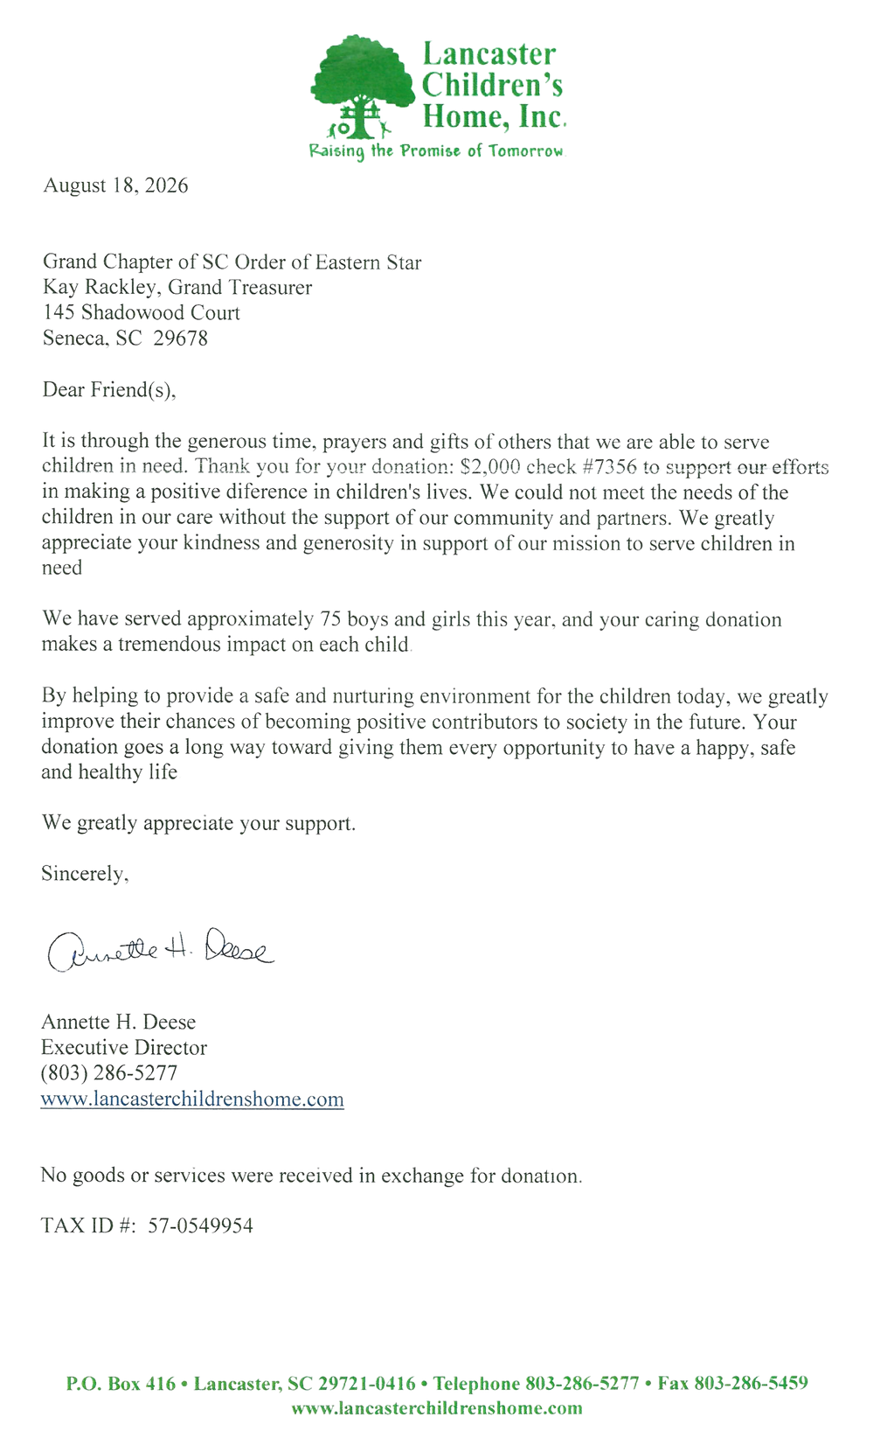

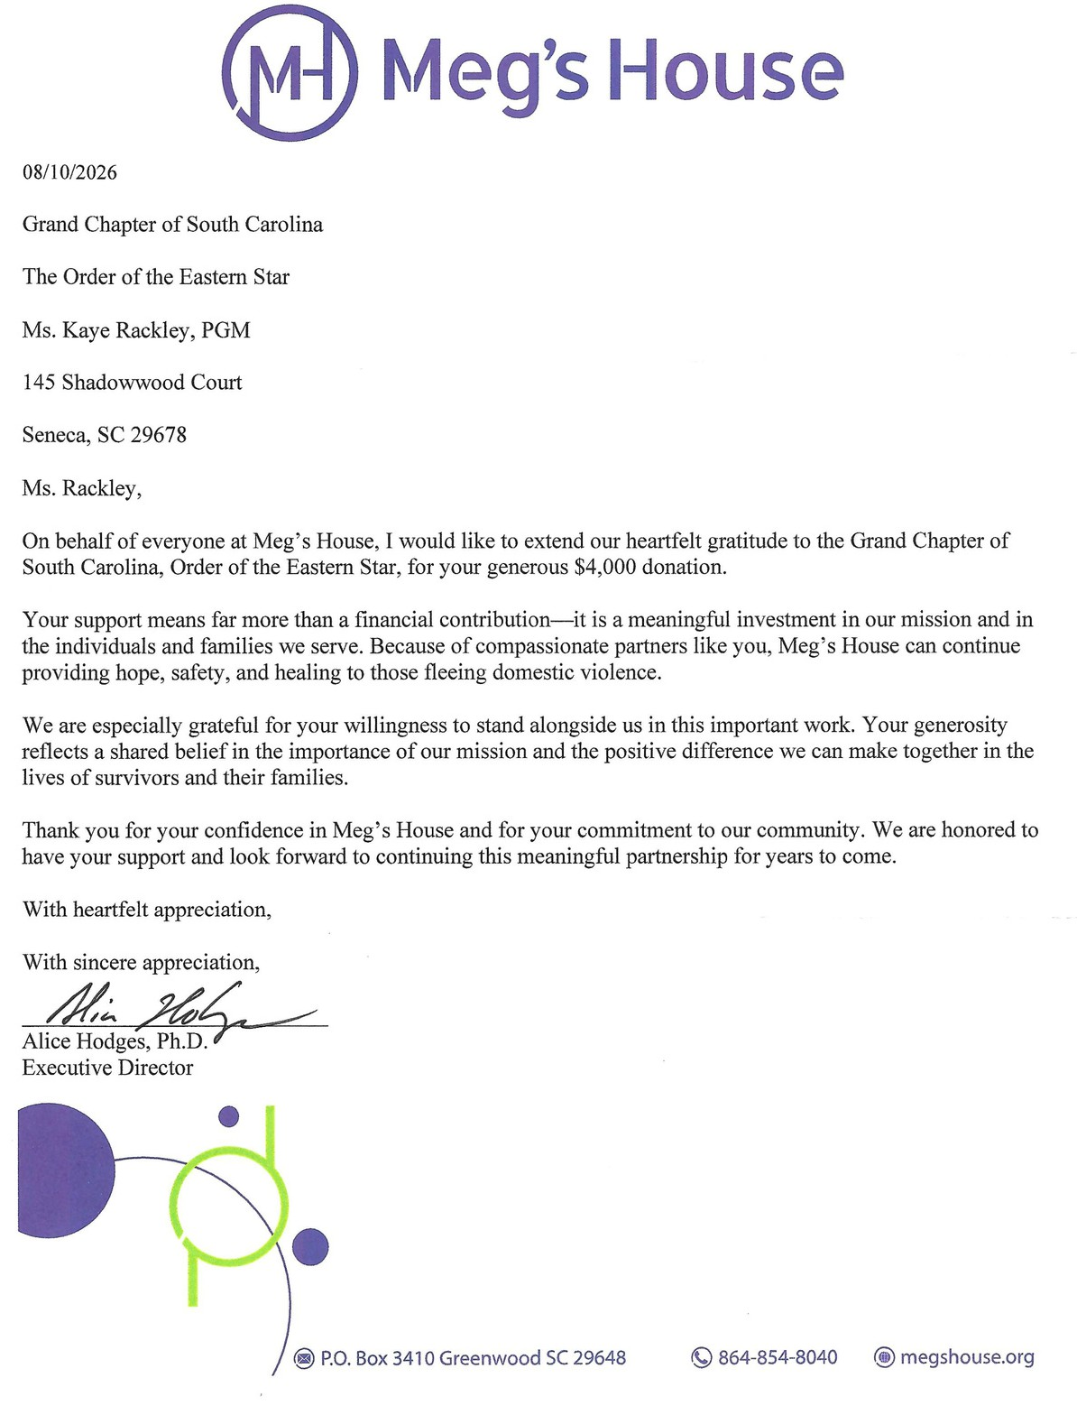

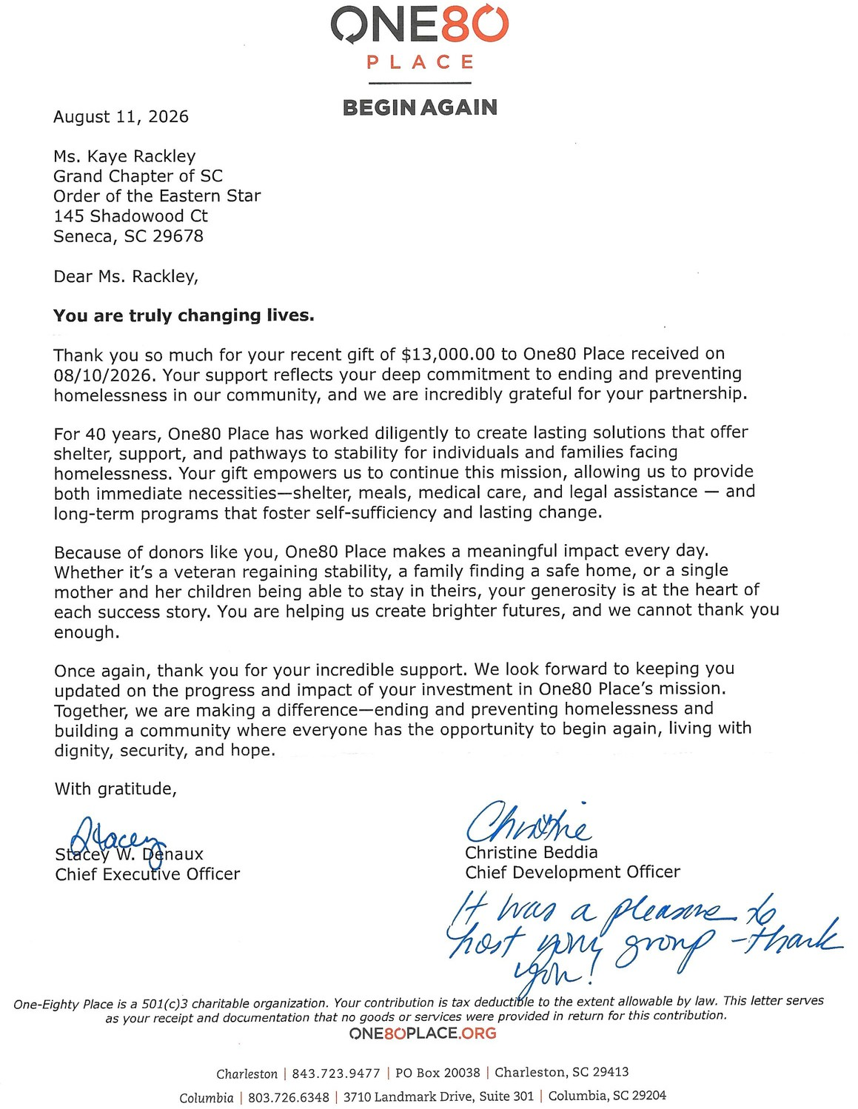
Volume 67 October 2026 Issue 10 Page 15

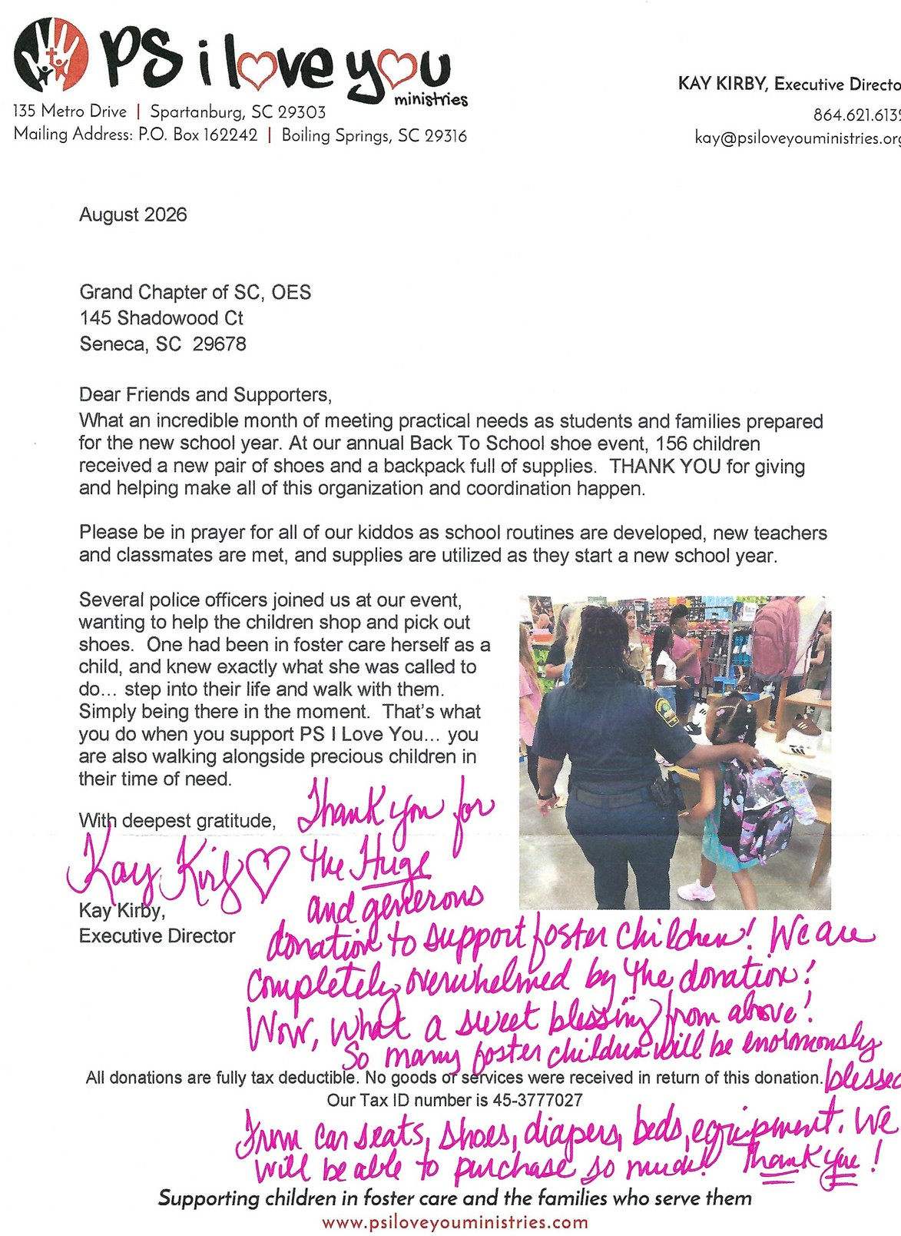
Volume 67 October 2026 Issue 10 Page 16

OP*FOB
7 Venture Dr, Ste 104-PMB 266
Bluffton, SC 29910

Grand Chapter of SC Order of the Eastern Star 145 Shadwowood Court
Seneca, SC 29678

August 14, 2026

Dear Grand Chapter of SC Order of the Eastern Star,
Thank you for your contribution of $13,000.00 on 8/11/2026.
Because of you, hope is within reach.
Your gift to OPFOB is more than generosity-it's a lifeline. It powers our mission to prevent veteran and first responder suicide, expands access to healing programs, and helps us create spaces where recovery is possible and community is strong.
With your support, we're launching transformative initiatives like the Wellness and Resource Center and our Service Dog program-each designed to restore purpose, connection, and resilience. You are turning vision into reality, and lives are being changed because of it.
We are profoundly grateful for your belief in this mission. Together, we are building a future where those who've served are never left behind.
With deepest thanks,

JR & Stephanie Brown, Co-Founders

Note our new address: 7 Venture Drive Ste 104-266 Bluffton SC 29910

All donations to 501(c)3 (federal tax ID #85-0894599) organizations are tax deductible to the extent allowable by law. The amount listed is your potential tax-deductible amount. Donor has received no goods or services. This donation will not be placed in a private foundation, donor advised fund or supporting organization. As with any donation, you should consult with your personal income tax advisor about your specific tax situation. Please keep this written acknowledgment of your donation for your tax records.

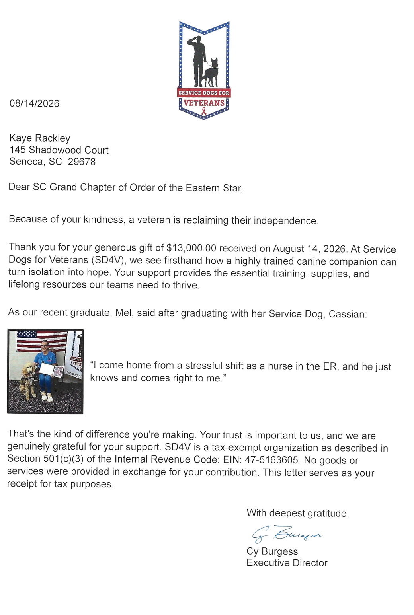

The Friendship Rose Club
The Friendship Rose Club met at the September 20, 2026, Line Officers Meeting with 23 in attendance. We had an abundance of Fall Baskets and Arrangements that sold, Spider Plant Puppies, and other crafts and home baked goods. Our table sales have been going well. Sister Lynetter Jenkins gave a preliminary report on our Pecan Sales and our Club surpassed the amount we sold last year, so Sister Judy and Brother Mike were well pleased.
The Club sang “Happy Birthday” Backwards to our Brother Mike Smith, Worthy Grand Patron. Many had not experienced a “Happy Birthday” sung backwards so it was a learning experience and fun for all.
Discussion was held in making plans for our Grand Chapter session which “will be here before you know it”. Sister Judy will announce to those that need to be there when the hotel planning meeting will be in November. We hope to have 300-350 in attendance again this year. Sister Judy reminded all that in November we will be having a Thanksgiving Feast for all in attendance and the different Line Officers Clubs of the items they need to provide. Brother Robert Kamphaus has agreed to help in cooking the Turkey and Ham for our Club.
Many names were lifted for. our Sick and Distress. The meeting was closed with all reciting the Mizpah Benediction.
Respectfully Submitted, Sister Dawn Blizard, Club PSN Reporter

 Message from Grand Chapter Medical Team 

As many know that we just had Ovarian Cancer Awareness in September. Several of our members have had this disease. Unfortunately, there is nothing that can be done to prevent it and diagnosis comes after many symptoms are present which means the cancer is advanced. If any females have bloating, constipation, decreased appetite, unplanned weight loss/gain or lower abdominal pain, please don’t ignore it and get checked out. If it is cancer, treatment can begin before it is too late.
This month (October) is Breast Cancer Awareness Month. Think Pink. This cancer hits home to many of our Sisters and Brothers in Easter Star. Many men are not aware that they can also get Breast Cancer and it can be genetics that can be the cause. As your Medical Team, we are encouraging everyone to perform self exams and if you notice a lump, hardened area, or discharge from your breast or even a small lump under your arm to get it checked out before it is too late.
There are many types of Breast Cancer and not everyone’s acts the same. The good news is that not all Breast Cancers require IV Chemotherapy. Some may be treated with surgery, oral medications, or radiation. Breast Cancer is no longer a life sentence for many who have it as research and treatment have come a long way. In addition to self exams, many insurance companies will now pay for annual mammograms if you are under 40 and have a predisposition to Breast Cancer.
If you have any health questions, please reach out to either Sister Susan Kirby, Sister Judy Boykin or myself and we will try to answer them or direct you to the right person.
Respectfully Submitted, Sister Dawn Blizard, Grand Chapter Medical Team

Charleston Chapter #56
Charleston Chapter had the honor of presenting our Charitable Giving Check to Beyond Our Walls which is next door to our lodge. This is a ministry that was started to help families in meeting the needs of after school care as well as helping form our youth to become respectful citizens. We shared with them what our organization does and how we chose them to be honored. We also found out that our virtues of Charity, Truth and Loving Kindness are values that they instill in their youth. We also let them know that we strongly support our youth as they are our future. We were able to meet many of the children that are served as well as receive hugs. This program not only supervises the children for after school, but assists them in reading and math as well as teach them music instruction and computer lessons in the afternoon. Many of these kids come from broken homes and are so appreciative of the love and support that BOW provides. We also shared with them how we can continue to be of service to them and look forward to our continued relationship with them in the future.
Our chapter had a first meeting since Grand Chapter and had a good crowd with hot dogs and sides for dinner, and a delicious Chantilly Cake that Sister Janet provided.
We received a petition for reinstatement and this Sister plans to be making the meetings as well as holding an office for our Official Visit in January. So are excited!
Respectfully Submitted, Sister Dawn Blizard, Secretary PSN Reporter
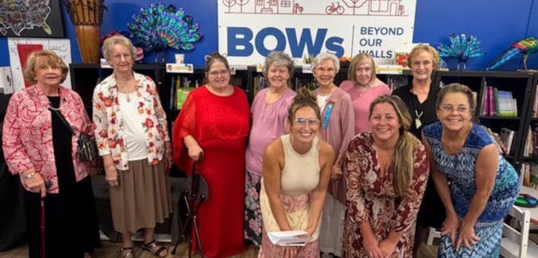
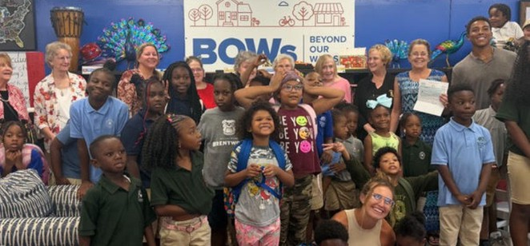

Easley #200
We had a busy, but good month at Easley OES. We met for our monthly fellowship meal at Silverbay in Easley and enjoyed some good food while we shared some laughter and fellowship.
We were honored to be asked to participate in the 150 year rededication of Bates Masonic Lodge. I just can't say enough about how much we appreciate our Masons! We provided dessert for the event and those of us that could, attended the ceremony.
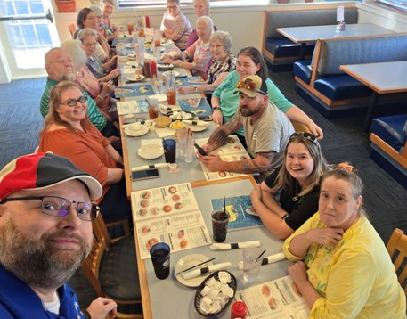
We just completed our Official Visit for 2026. We had a great time and appreciate all of those that came out to visit and participate.
We meet the second Monday of every month, and have a monthly fellowship meal on the 4th Tuesday of each month. We would love for you to come join us anytime!
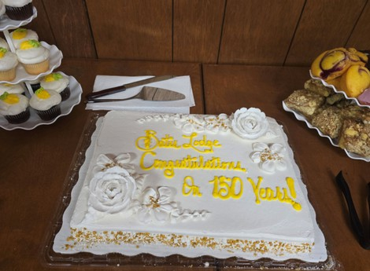
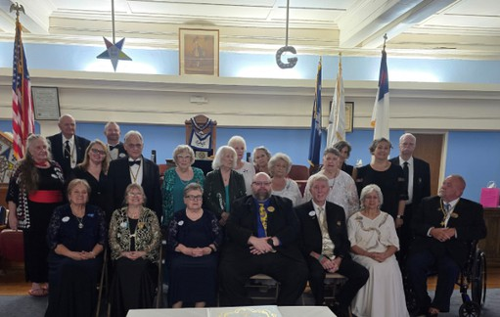
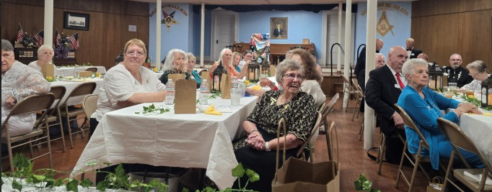

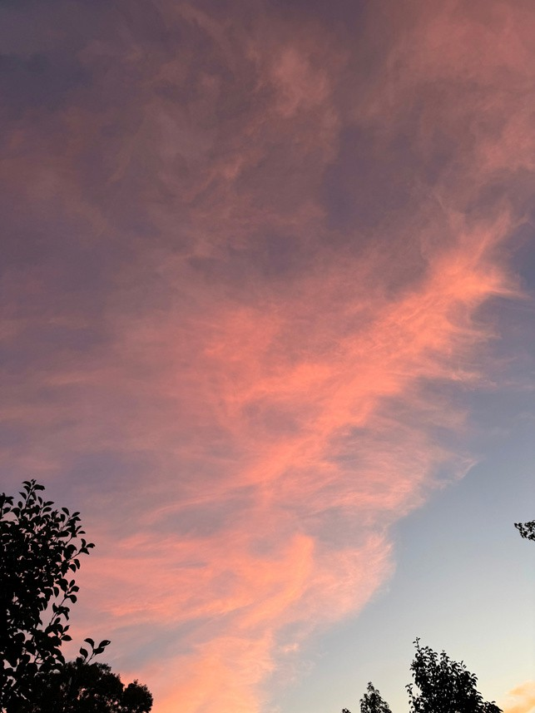
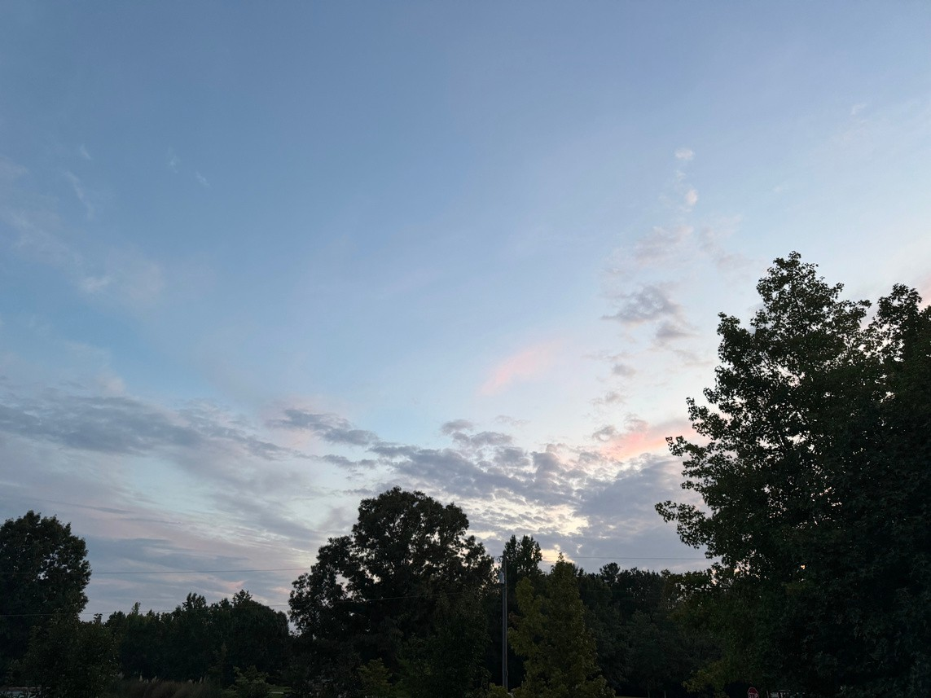

Pictures from SC OES Members
After the Storm
Before the Storm


Lexington Deer
Alaskan Sky

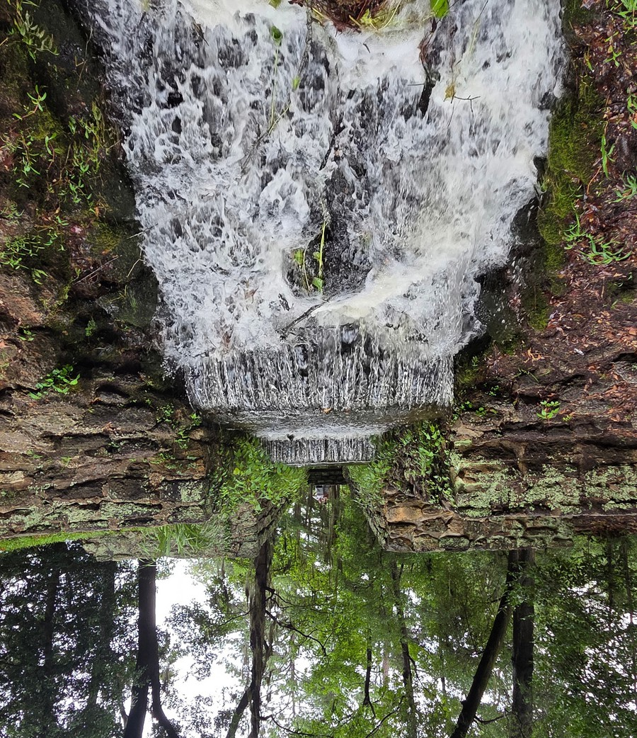
Palmetto Star News
BULK MAIL US POSTAGE PAID
PERMIT NO. 595 COLUMBIA, SC
Volume 67
October 2026
Issue 10
Page 23
Pictures from SC OES Members
Waterfall in a
Sumter Park

2050 Old Cherokee Road
Lexington, SC 29072

