
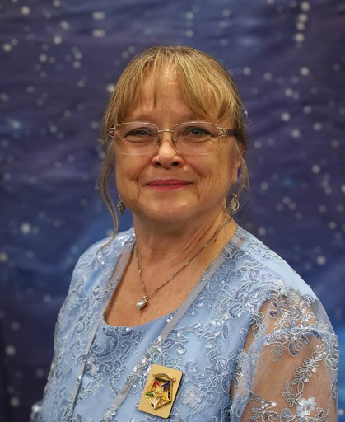

Palmetto Star News
N
A
O
R
D
E
R
o
f
t
h
e
E
A
T
E
R
o
f
S
O
U
T
H
C
A
R
O
L
I
Volume 67 September 2026 Issue 9
S
T
E
R
N
S
D
C
H
A
P

News from the Worthy Grand Matron
T
A
R
G
R
A
N
Hello Sisters and Brothers! I hope you have had as much fun as I have this
month. It has been very busy.
On August 1 we had Popeye School of Instruction #4, at Dixon Chapter. The districts that hosted were #1, 6, and 9. Everything was ready for us and the school went well. We had 84 members attend this school. I am very happy with the participation this year.
On August 6 there was a Charitable Giving Presentation to Operation Patriots FOB (Forward Operating Base). Sponsored by Lillie Chapter. Don Cool PGP, Grand Lecturer presented the check along with Sisters Durena Marcum, Jennifer Bailey Gr. Conductress, Judy Boykin Gr. Martha, Milly Cool. Their mission is to help first responders, Active duty, and veterans and family members who suffer from PTSD.
On August 7 we traveled down to Charleston to One 80. Sponsored by Loyalty Chapter. Their mission is finding a solution for the unhoused, and to provide food, lodging and safety. They have several areas in Charleston where they can help people from that area. It is a fantastic facility and a lot of the needs are met daily. Those at the presentation included myself, Mike Smith WGP, Kaye Rackley, PGM Gr. Treasurer, Fred and Anna Armstrong, Josiane Horton, Gr Trustee, Lynette Jenkins, Gr Trustee, Don Owens Gr. Sentinel, Angie Owens, Mr. and Mrs. Susan Brady, Valerie Weeks, and Beth Gibbs.
On August 8 the Milkyway School of Instruction #5 at CCMA Districts 13-15 was held. Great school. We had 81 members in attendance. However, the districts out did themselves with that dessert table - WOW! No one walked away hungry. Such a great day with my sisters and brothers. We also announced the Grand Trip which I will tell you about at the end.
On August 12, another Charitable giving presentation was given to Hope Mission of the Upstate in Anderson. Sponsored by Anderson Chapter. They serve breakfast 6 days a week to anyone with warm coffee and conversations. They also provide some medical help when needed and open their doors as a warming center in the winter when the temperature drops so they have some place to go. There is a picture of the presentation in this newsletter.
On August 14 we traveled to Spartanburg in the morning to P.S. I Love You, sponsored by Roebuck chapter. This charity supports the needs of Foster Children and the families who care for them.
They provide clothes, personal needs and give them a feeling of self worth during the most difficult time in their short lives. Great operation, very organized. Those present were myself, Mike Smith WGP, Anita Dixon AGM, Mark O’Shields AGP, Kaye Rackley PGM, Gr. Treasurer, Lynette Jenkins Gr. Trustee, Josiane Horton Gr. Trustee, Kim Desrosiers AGC, Ann and Randy McKendrick, Linda Hoover, Barbara Sanford, and Julie Bowker.

After a great lunch we made our way over to Greenville for another Great Charitable Giving Presentation to Service Dogs For Veterans, sponsored by Dentsville Chapter. Here the service dog and the veteran train together and build a bond and rely on each other. It helps the veteran to cope with day to day activities. The dog helps the veteran when the nightmares and loneliness and when bad memories return. Those present for the check presentation were myself, Mike Smith WGP, Anita Dixon AGM, Kaye Rackley, PGM Gr. Treasurer, Kim Desrosiers AGC, Fred Armstrong PGP, Ch. Gr. Trustee, Lynette Jenkins Gr. Trustee, Josiane Horton, Gr. Trustee, and Julie Bowker. There were 4 veterans with their partners at the presentation and they gave us a demonstration. It was a great day all around.
On August 21 we travelled down to Aiken for a presentation to The Children’s Place Inc. sponsored by Golden Glow Chapter. Their mission is to protect, heal and strengthen children from the impacts of trauma in their lives. This Charity serves 5 counties. Through education, mental and physical treatments and prevention services they are able to offer help and love while caring for their needs. Those present were myself, Kaye Rackley PGM Gr. Treasurer, Lynette Jenkins Gr.
Trustee, Judy Justice, Robert Justice, Debbie Kenny, Christen Greenway, Jeff Greenway, Maggie Kilby.
On August 22 the Grand Officers were asked to perform an initiation for 9 members of Lyman Chapter and 3 members for Greer Chapter. We were so proud to do it. And now we have 12 new sisters and brothers. We performed the ceremony twice with 6 members each. After it was over, we all enjoyed a great lunch provided by the Chapters. It was an Epic day. We had 64 members present, some from the chapters who gained new members, the Grand Officers, and members from around the state to witness the event. So Proud.
On August 28 we travelled to Myrtle Beach to the Helping Hands of Myrtle Beach Inc., sponsored by Myrtle Beach #180. The mission of this charity is to support basic needs of the community, to provide and assist with rent, utilities, transportation and provide 5 days worth of emergency food to fill a short term need.
On August 29 North Star School of Instruction #6 - District 20 @ Loris chapter. This was the last school of the year. We had 64 members attend this school. Brother Don Cool, PGP Grand Lecturer has led us and schooled us all summer long. Our officers and Deputy Grand Marshall’s did a super job for this school and we were honored to let them shine. District 20 and Sister Debra Caesar did a beautiful job hosting. They were great at remembering to recycle, reuse and repurpose, all things. My thanks to that great effort.
After we finished the school the Grand Officers honored our Grand Lecturer with a roast of all we had learned from him. Brother Don Cool, PGP I want to thank him for his dedication to this task. Each week was different, and he adjusted to the changing scenarios. I am so happy you agreed to be our Grand Lecturer.
As August comes to an end. I look forward to September. We will be starting our official visits. Our inspecting Grand Officers are so excited to come and visit you and get to know each and every one of you.

We shall see you on the road very soon. May God Bless on your travels.
Remember to show G.R.A.C.E. - Grand Respect And Compassion to Everyone. We cannot possibly know what someone that is close to us is going through. But if we give GRACE and understanding without judgement, there is love behind our reasons.
May God Bless you and yours. Judy M. Krummich WGM


OFFICIAL VISIT
You're Invited!
You're Invited!
Nell Chapter No. 251 Invites You to the Official Visit of
Judy Krummich, WGM Mike Smith, WGP
Saturday, September 5, 2026 Courtesies and Pictures 11 AM
Banquet Noon Meeting 1 PM
Fountain Inn Lodge #192 108 N. Weston Street Fountain Inn, South Carolina
Janice Gibson, Worthy Matron, PGM Daniel Swords, Worthy Patron
Virginia Medlin, District Deputy Merle Blevins, DGM to District Deputy

OFFICIAL VISIT
Richburg Chapter #213
Saturday, September 19, 2026 Meal At Noon - Meeting To Follow Lisa Passmore, WM
Steve Bairefoot, WP Judy Krummich, WGM Mike Smith, WGP Kathy Wallace, DD #8
Home Chapter Of
Associate Grand Conductress, Kim Desrosiers Grand Representative of
Michigan, Kelly Barnes Grand Representative of
Rhode Island, Ruthayn Burdette Grand Representative
of Vermont, Lisa Passmore Dual Chapter Of
Grand Warder, Ricky Doby Special Grand Page to

the Grand Warder, Jamie Hyman

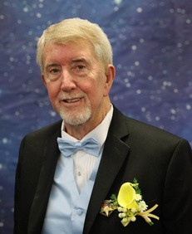
News from the Worthy Grand Patron
Greetings to all my sisters and brothers. What a time it has been already. As of this posting we have completed 5 of our 6 schools and are anxiously looking forward to our last school at Loris Chapter. Brother Don Cool has done an excellent job in preparing for the schools and the Grand Officers have carried out the instructions in an excellent manner. Attendance at the schools has been good. Dixon had 86 in attendance and Berkley came in at
83. I have enjoyed traveling around and visiting the chapters in my district as well as the surrounding districts.

The Official Visits begin on September 4 at Tallulah Chapter in Spartanburg, SC. Followed by Nell Chapters OV the next day. Check your itinerary to see when and what is happening. If you haven’t purchased one yet I encourage you to see your District Deputy and purchase one so you can keep up with what is happening. Get 2 while you are at it and keep one in the car. You never know when you may want to look at something. Pecan orders are being taken now. Please get your orders turned in. We must turn them in at the September Line Officer Club Meetings so they can get to us by November. Bee safe in your travels and see you on the road.

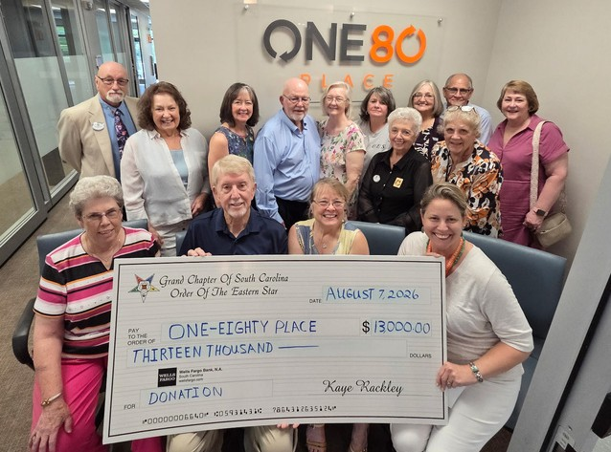
Charitable Giving Presentation

One Eighty (180) was a check presentation to that charity. The Star members who attended and took a tour of the facility are pictured with the representatives of the charity. They run an amazing program to provide services for homeless in Charleston and were so grateful for our generous donation.

Volume 67 Septermber 2026 Issue 9 Page 5


ITINERARY CHANGES

Grand Representatives
Hillarie Vaughn to Pennsylvania add to page 38, 147 Cherokee Hills Court, Lexington, SC 29072
Tammy Grice to Alberta Canada add to page 34, 290 Mossborough Dr., Lexington, SC 29093
add Charles Lott, SGP to WGP to page 7, 646 Jackson St., Barnwell, SC 29818, ph 803-300-0740 Harmony Hope D-9
- add Kaye Rackley to page 11
- change Ann Satterfield’s e-mail to annrsatt@yahoo.com
- add Kim Desrosier to page 13 as Associate Grand Conductress
- add Joisane Horton to page 16 as Grand Trustee
- add Don Ownes to page 27 as Grand Sentinel
- add Kim Desrosiers to page 45 for Fraternal Correspondence
- add Holly Schneider to pag 46 - phone number update 803-513-0022
- add Marty Nielson to page 46 as Web Master. See page 17 for information
- add Bobbie Kinard to page 47 as Elected Assisted Care Board Member - information on page 24
- add Charlene Sena PGM to page 47 as Elected Assisted Care Board Member - information on page 33
- add Paula Still to page 47 as Elected Assisted Care Board Member - information on page 22
- add Don Owens to page 51 as Grand Sentinel Chairman - information on page 27
- change page 64 Nell Chapter #25 meeting night is 1st Thursday
- change DGM for D-20 to Linda Hamilton page 72
- add Robert Storey to page 41 to Benevolence Committee

EVENTS
- page 75 Delete Harmony Hope O.V. on 9-8 they have combined OV with Golden Glow on 9-10
- page 75 Add Nell #251 OV on 9-5 and delete OV on January 16, 2027p
- age 75 add Richburg #213 O.V. for AGC Kim Desrosier
- page 75 9-21 move Lillie OV to February 15, 2027
- page 75 10-6 move Charleston #56 O.V. to January 18, 2027
- page 75 10-8 moves Greer #151 O.V. to February 11, 2027
- page 75 10-12 move Glendale #175 to November 20, 2026 combined ov with Reidville #46 11-
20-2026
- page 76 add Don Owens to Berkeley OV as Grand Sentinel
- page 76 move Corinthian #297 to November 3, 2026 First Tuesday
- page 77 12-8 delete lexington #176 OV moved to January 30, 2027
- page 77 12-14 delete Richburg #213 moved to September 19, 2026
- page 77 1-16 delete Nell #251 moved to September 5, 2026
- page 78 1-18-2027 add Charleston #56 OV
- page 78 1-30-27 add Lexington #176 OV New Grand Trustee
- page 78 2-11-27 add Greer #151 OV
- page 78 2-15-27 add Lillie OV

UPDATE ON DEFENDERS FOR CHILDREN and Chip
This is an update on the dog we named through our Charitable Giving donation to Defenders for Children. Chip and handler Benji are working hard to protect children.
SOUTH CAROLINA WILL SOON HAVE THREE STATE ESD K9s!
After two remarkable years serving with the South Carolina Department of Probation, Parole and Pardon Services, Special Agent Benjy Partain and K9 Chip have taken their extraordinary skills to SLED’s "South Carolina Law Enforcement Division" Special Victims Unit.
There, Chip will help investigators locate hidden electronic evidence in cases involving crimes against children, child exploitation, human trafficking, child fatalities, and the murder of children. Chip will also provide comfort and support to child victims, families, and the professionals who investigate these heartbreaking crimes.
But the need continues to grow. Because of the overwhelming workload and the proven impact of these highly trained K9s, Defenders For Children is preparing to place two additional Electronic Detection K9s with Probation, Parole and Pardon Services.
That means South Carolina will soon have:

🐾 K9 Chip serving with SLED
🐾 Two new ESD K9s serving with Probation, Parole and Pardon Services
Three state Electronic Detection K9s working to uncover hidden evidence, strengthen investigations, protect children, and help bring dangerous offenders to justice. This is a major step forward for South Carolina—but we cannot
do it without our donors, sponsors, and supporters. Together, we are expanding the pack and strengthening the fight to protect children
across our state.
Meet the newest members of
SLED's Special Victims Unit - ABC Columbia

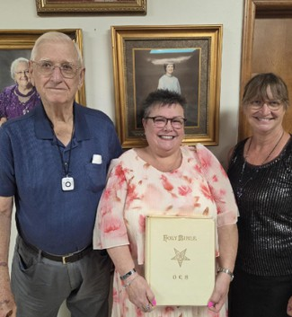
Richburg #213

Touching Presentation
Brother Wayne Tucker was not feeling well and was unable to attend Richburg Chapter 213's July meeting as planned. Sister Beth Jack presented Sister Peggy Tucker’s travel Bible to Sister Kim Desrosiers, AGC on behalf of the Tucker family. Pictured are Brother Wayne Tucker, Sister Kim Desrosiers, AGC and Sister Beth Jack with Sister Peggy Tucker’s Worthy Grand Matron portrait in the background.

TALLULAH 16
We were honored to have Sister Kaye Rackley, Grand Treasurer, meet with us in Clinton, SC, to present a check for $4,000 to, our nominated charity for GC - OES, OPEN DOOR CHRISTIAN CENTER on July 25.
They were very appreciative of our donation! WM Elke Lester, AM Pat Alloy, AP Art Alloy, Secretary Barbara Sanford represented Tallulah 16.
We had a delicious fellowship meal prior to our regular scheduled meeting August 9. We discussed plans for our Official Visit on September 4. We welcome our sisters and brothers to join us as Sister Anita Dixon will be our inspectiing officer with Brother David O’Shields joining her.
Star Love, Barbara Sanford, Secretary
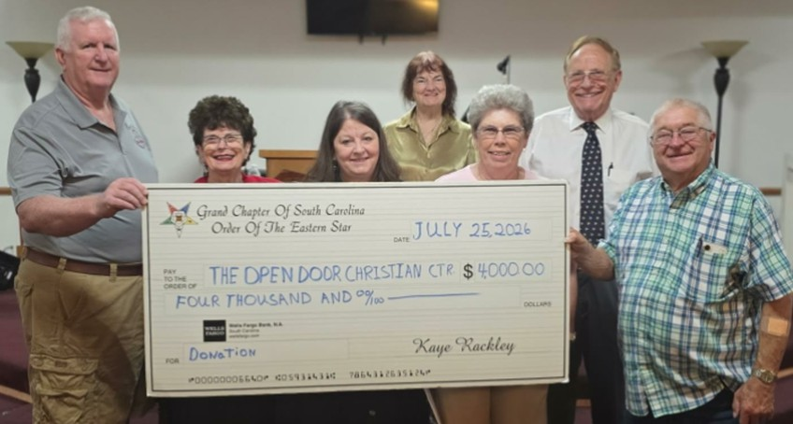

Antioch #291
Antioch Chapter #291 submitted the Lancaster Children’s Home to the charitable giving committee for consideration. After Grand Chapter, we received the donation check to be presented to them. On August 7, 2026, several members of Antioch Chapter was able to take the donation to the Children’s Home. They were very appreciative for the donation. We were proud to be able to take them this donation. They were also very grateful we submitted them for consideration.
Pictured here presenting the check are Antioch members: Bridget Sims, WM, Melba Sims, secretary, Jessie Hill, Becky Collins, and Lynn Knight. Also pictured is April Joplin, Director of Community Development, Annette Deese, Executive Director, and Beverly Caskey, Program Director of the Lancaster Children’s Home.
Bridget Sims, WM, Antioch Chapter #291
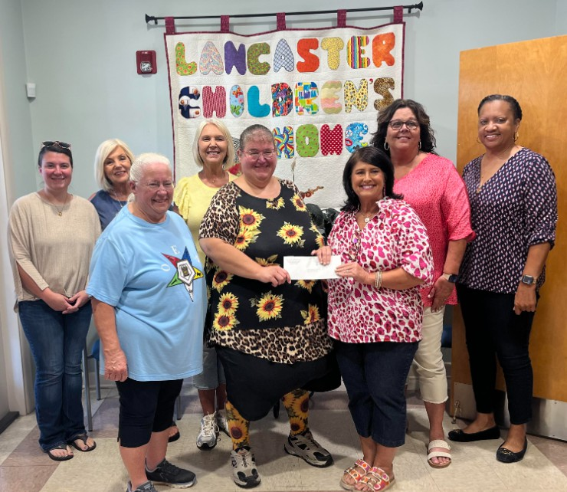

Seneca #5
Seneca #5 had their regular stated meeting on August 18, 2026. We had 17 members and visitors present. We shared a delicious potluck meal and wonderful fellowship. Sister Kaye Rackley, PGM shared some information on the triangle we create during our meeting and it's purpose along with further instruction on the things we do and share - it was very interesting and informative. Sister Kaye gives instruction at all our meetings now to instruct and remind new people and old the proper way to do things within our order.
We had a wonderful meeting and discussed many things. We met with our charity, First Light, to present them with the $500 check that was awarded them by Grand Chapter. They were so surprised and grateful for the help we have given them. We are collecting large print word search books for Foothills Assisted Living if anyone wants to help. These residents love to see us coming with the books and new puzzles.
The last school is next weekend and we are excited about the Official Visits about to start. Seneca #5 is already making plans for ours. Please come out to as many as you can. They are so much fun. Safe travels to everyone and may God bless you.
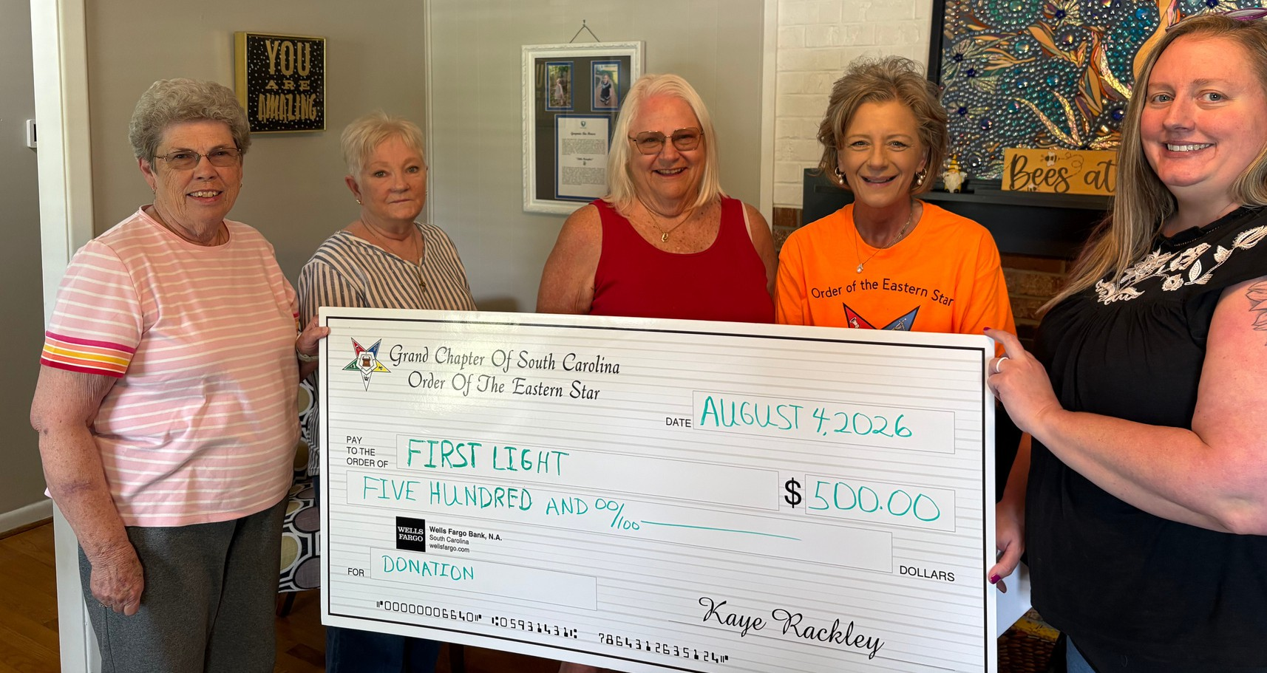
Star love, Patty Alger PSN reporter

Past Appointed Grand Officers Club (PAGO)
The PAGO Club met on August 2, 2026, 3 p.m. at Grecians Gardens in Columbia, SC with 22 members and guests present. We had three new Past Grand Officers of the Jackson 2025-2026 Family present and joined.
Meeting was opened with prayer led by Brother Don Cool, PGP, and pledge was given. Members were encouraged to purchase Club pins for $5 and to pay this year’s dues of $5. Treasurer’s Report was given. Minutes of previous meeting and report on Grand Chapter luncheon was given by Sister Heather Kamphaus. Membership report we have sixty paid memberships so far this year.
Elections were held and the following were elected or reelected for the next year: Sister Sherry O’Shields, President, Sister Heather Kamphaus, Vice President, Sister Bridgette Sims, Treasurer, Secretary no nominations accepted at the time, Brother Don Cool, PGP, Chaplain. Motion was made for Sister Heather to text a nominee for Secretary and accepted. Sister Dawn Blizard accepted Secretary for next year.
Sickness and Distress names were called up with prayer given. Motion was made to donate $25 in honor of Sister Jane Huggins, President 2025-2026 for all her hard work to be given to Lancaster Children’s Home which has a special place in her heart.
Good of the Order was given. October 4, 2026 will be our next meeting at 3 p.m. All are invited back and to bring a friend. Reminder that Grand Representatives Club will meet August 9, 2026, at Lizard’s Thicket in Lexington. Meeting was closed with Mizpah Benediction.
Respectfully,
Dawn Blizard, Secretary/Reporter

The Friendship Rose Club
The Friendship Rose Club met at the first Line Officers Club meeting of the year on August 16, 2026, 3 p.m., at Dentsville Lodge. We had a large turnout not just for the club but for the Line Officers Meetings. The Line Grand Officers thanked all for coming and their support.
Sister Judy allowed Sister Nancy to give information on the sale of pecans for this year. It was announced that the Line Officers Clubs would be selling Chocolate Covered and Salted Pecans again this year. With the way the weather has been, the price for each bag will be $12, $288 a case of 24 bags. You may purchase full cases or partial cases and mix the two choices as well.
The profit per bag will be announced at the November Line Officers Meeting. All were encouraged to go ahead and place their orders now with payment due to the respective clubs by end of September so the numbers can be turned in to Sister Nancy.
The attendees then enjoyed a delicious lunch of hot dogs, sides, cold beverages, and plenty of desserts provided by The Friendship Rose Club. The meeting was opened in prayer with previous minutes and treasurer’s report given. The Club then moved into elections for the 2026-2027 year with the following being elected to serve: Sister Joy Thibedaux, President; Sister Heather Kamphous, Vice President; Sister Awone Rector, Secretary; Sister Shane Patterson, Treasurer; Brother Larry Brantzeg, PGP, Chaplin; Project Table Sister Josiane Horton, Sister Cindy Leitner, and Sister Carole Lovece; and Sister Dawn Blizard, PSN Reporter. Sister Lynette Jenkins generously accepted to be the Pecan Chair for the Club this year and will also be at the lodge when the pecans are delivered to help Brother Willis Jenkins sort them by clubs.
Sister Judy discussed her and Brother Mike’s plans for the upcoming year and what the Club Funds will be used for. Members were encouraged to bring crafts, baked goods, seasonal items and money to spend at our next Line Officer’s Club craft table. Sister Judy stated that at the next meeting it would be discussed as to what the club would be responsible for at the November Meeting/Thanksgiving Meal.
Sickness and Distress given with prayers lifted. All joined hands and the meeting was closed with the Mizpah Benedictions.
Next Meeting will be September 20, 2026, at 3 p.m. at Dentsville Lodge with craft tables opening up at 2 p.m.

Respectfully submitted, Dawn Blizard, PSN Reporter
In Memoriam
Please keep the family and friends of Lowell McDaniel, PGP, Easley 200 in your prayers:

Grand Representatives Club
The Grand Representatives Club met on Sunday, August, 9, 2026, at Lizard’s Thicket Restaurant. We had 23 in attendance and so thankful for the large crowd. We had five Grand Officers present, Sister Anita Dixon, Associate Grand Matron; Sister Lynette Jenkins, Grand Trustee; Sister Josiane Horton, Grand Trustee; Brother Don Cool, PGP, Grand Lecturer; and Brother Fred Armstrong, PGP, Chairman of Grand Trustees. We had six current Grand Representatives present, 15 past Grand Representatives present, and two visitors. We are thankful for everyone taking time out of their busy schedule to spend with us.
Two of the biggest things on the agenda were the Election of Officers and Discussion of the Luncheon for next year. The following officers were elected or reelected to serve for the following year, Sister Josiane Horton, President; Sister Lynette Jenkins, Vice President; Sister Susan Irby, Secretary; Sister Sherry Jones, Treasurer; Sister Lois Sills, Chaplain; and Sister Dawn Blizard, PSN Reporter. Sister Anita gave a report on the luncheon for this past Grand Chapter Session and reported that we had 144 in attendance and gave out many honorary memberships and pins to visiting Grand Representatives from Other Jurisdictions to Other Jurisdictions and South Carolina.
Table favors provided by the club were hand fans and they asked the club to consider and approve the use of the remainder for next year’s luncheon as plenty were left over. Comments were allowed to commend the enjoyment of the different table decorations to represent the theme “On the Road Again.” Also, positive comments were given to Sister Lynette on her Road Trip around the room with the Grand Officers and General Grand Chapter Officers and Committee Members who chose to ride along. Suggestions were taken from those present for the theme for next year’s luncheon.

With keeping with the Grand Chapter Session theme of “Look Up to the Stars,” great suggestions were given. The club voted and the theme will be “To Infinity and Beyond” as when you look to the Stars, there is no end to the Universe in sight, so it is infinity. With that, everyone is encouraged to decorate their tables as they see fit for the theme.

Sister Josiane also began taking names for Table Hosts for next year. The tables will again seat eight and the club will provide table favors of hand fans again and all hosts are encouraged to have a token favor for their guests. The Entertainment will include the Grand Officers, and they will be notified later of their role and the plan. You do not want to miss next year’s luncheon.

Many names were called up for Sick and Distress with Sister Lois providing prayer. All stood, held hands, and recited the Mizpah Benediction for closing.

Our next meeting will be held November 8, at Lizard’s Thicket in Lexington at 3 p.m. All are invited to attend and bring a friend or guest. They do not have to be a member of Eastern Star to enjoy good food and fellowship.
Respectfully Submitted,
Dawn Blizard, Club PSN Reporter

Grand Trip 2027 - March 1-4, 2027
The Worthy Grand Matron and Worthy Grand Patron are excited to announce their Grand Trip. Please join us for an exciting 4 days and 3 nights bus trip to the St. Augustine, Florida area.

MARCH 1 - 4, 2027.
Total Cost is $550 per person with double occupancy. You do not want to miss this trip!
Day 1: Board your spacious, video and restroom equipped Motorcoach and set off for the sunshine of Jacksonville, Florida! Upon arrival, you'll enjoy Dinner and check into your Jacksonville area hotel for a three night stay.
Day 2: After a Continental Breakfast, enjoy a scenic drive along the coast accompanied by your guide. Learn about the Kingsley plantation and Florida’s unusual history as you head to AMELIA ISLAND, southernmost of the Atlantic coast barrier islands. After taking a GUIDED TOUR of this beautiful island, you’ll visit the historical district in Fernandina Beach and have an opportunity to stroll along this stunning beach. This evening, enjoy a Dinner Party with Entertainment.
Day 3: After enjoying a Continental Breakfast, your journey begins with a GUIDED TROLLEY TOUR OF ST. AUGUSTINE, which offers a fascinating glimpse into the city's past and its stunning architectural marvels. The tour also includes admission to the St. Augustine History Museum, providing further insight into this historic location. Following the 90-minute TROLLEY tour, enjoy the flexibility of Hop-On/Hop-Off privileges on the TROLLEY for the rest of the day, allowing you to explore all of St. Augustine at your own pace. You can choose to stop at numerous historic landmarks including, but not limited to, the Old Jail, Potters Wax Museum, City Gates, St. George Street, Churches, Lightner Museum, St. Augustine Distillery, San Sebastian Winery, Plaza de la Constitucion, The Oldest House, The Marina, Ripley’s Believe It Or Not, and the Fountain of Youth. (Please note the admission to these additional museums and attractions along the trolley route is on your own.) You’ll relax and enjoy dinner at a local area restaurant.
Day 4: After enjoying a Continental Breakfast, you’ll depart for a NARRATED CRUISE on the ST. JOHN'S RIVER. Later, you'll depart for home... a perfect time to chat with your friends about all the fun things you’ve done, the great sights you’ve seen and where your next group trip will take you!
Please contact Sister Barbara Collins to get your name on the list. The first 52 names will fill one bus. If more are interested we will start a wait list. A second bus will be available if we reach 75. Dates of when deposits and final payment are required will be sent out tomorrow.
ALL CHECKS MADE OUT TO BARBARA COLLINS. Cash payments will also be accepted. ALL Deposits are fully refundable if the trip cancelled.

Barbara Collins, 843-200-5248
Phil Collins, 843-200-5247 Email: pbstcollins@homesc.com Address: 363 Jimmy Hill Rd., Cordesville, SC 29434
FINAL Payment is due on or before 12-18-2026. A deposit of 1/2 the per person due by 10-1-2026. You may send in the total amount at any time.
The first 52 deposits will guarantee your trip.
We will start a waitlist after 52, until we reach 75 for a second bus.

Easley #200
It is hard to believe September is already here! We had a busy August at Easley, and I know September will be busy too!
This month, we delivered all requested school supplies to East End Elementary to help them start the school year right. We participated in Lodge clean up day, and will join with Bates Lodge to celebrate their 150 year rededication on August the 22.
Our Official Visit will be September 14 at 6:30 p.m., and we hope as many as are able will attend.
This month we lost Lowell McDaniel. Lowell was a member of Easley and a PGP of SC. We will miss him and remember his many contributions to the community and the Eastern Star.
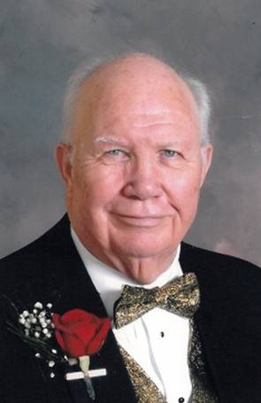
Prepared by: Susan Irby
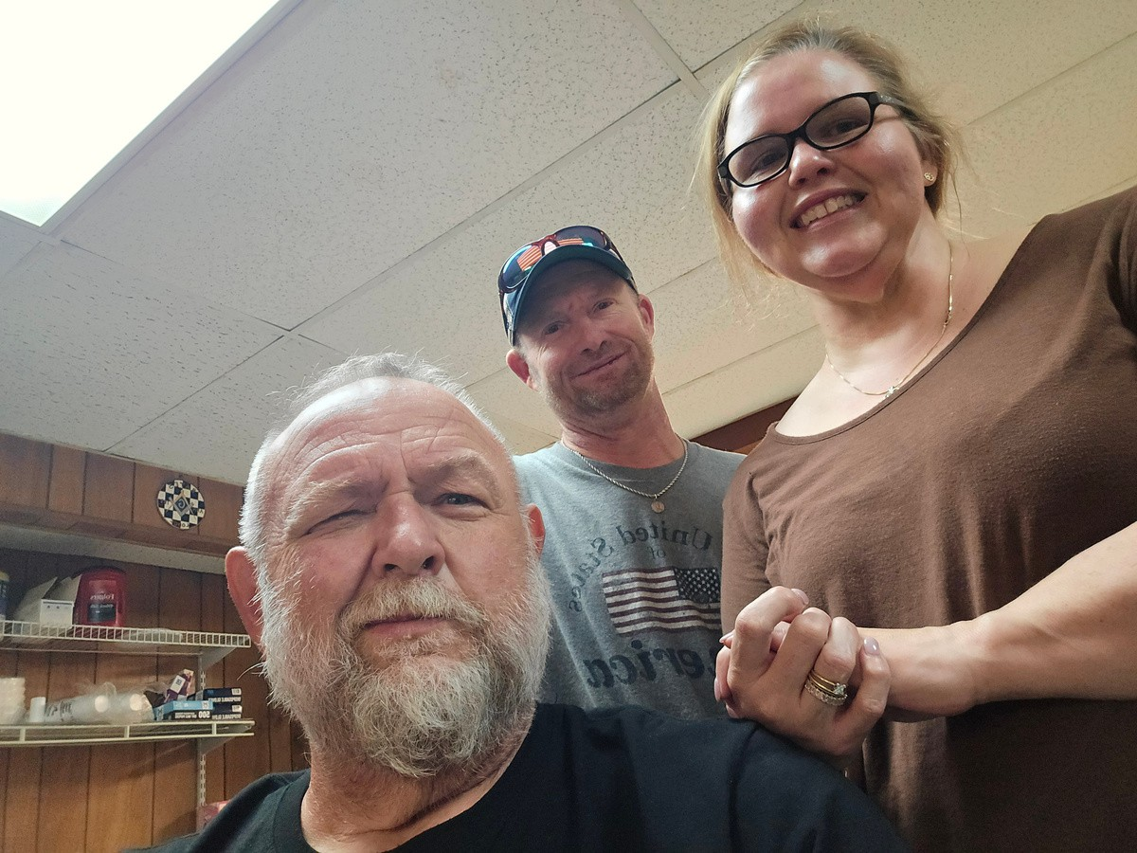
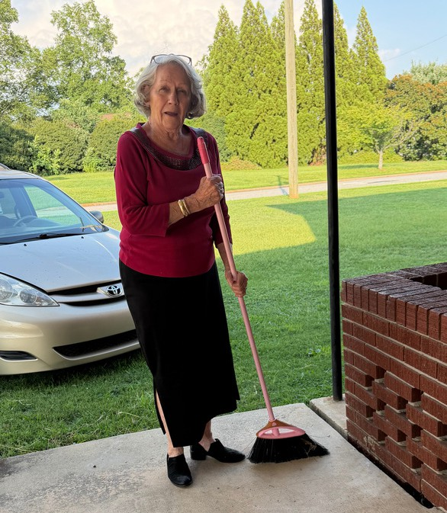
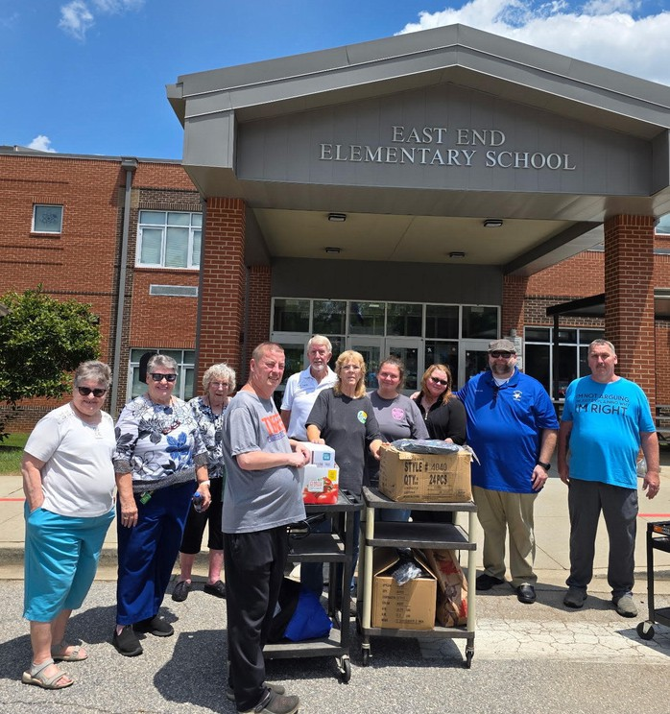

Charitable Giving Presentation
Don and Millie Cool, Durena Marcum, Jennifer Bailey and Judy Boykin had a wonderful tour of Operation Patriots FOB, in Ridgeland. Their main goal is support of our veterans and first responders through peer support while engaging in outdoor and recreational activities. We toured and talked for nearly three hours, viewing fishing ponds, walking trails, shooting ranges, cabins and an enormous barn - where events such as AA, Yoga class and Bible study are held. A deserving recipient of our support. Thanks to Durena for the suggestion.
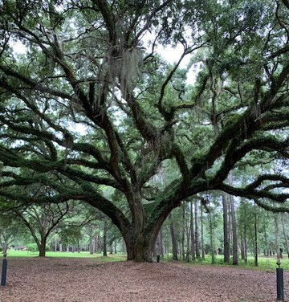
Judy Boykin
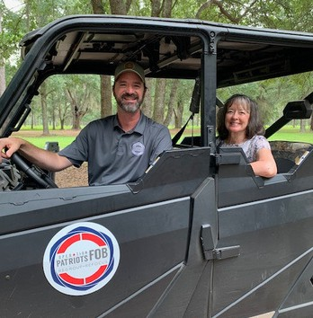
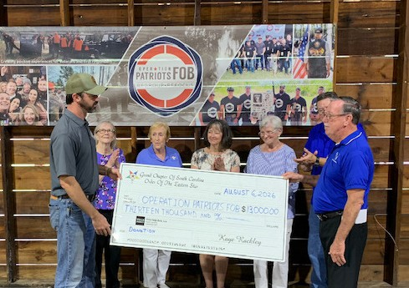

Anderson #130 OES Visit to Hope Missions
On Wednesday, August 12, 2026, Anderson Chapter #130 Order of the Eastern Star, District 2, was privileged to be a part of a presentation of a check for $13,000 payable to Hope Missions in Anderson, SC. It was such an honor and blessing to get to see the reaction of Dave Phillips and Zoe Hales when they were presented with the check. There were many from the Hope Missions organization present during the presentation. Representing Anderson Chapter #130, Tammy Rigsby, WM; Awone Rector, Secretary; and Kerri Holland, Martha. From Grand Chapter, Mike Smith, WGP; Kaye Rackley, PGM/Grand Treasurer; Fred Armstrong, PGP/Grand Trustee; and Kim Desrosiers, Assoc. Grand Conductress. Thank you to the Order of Eastern Star for how the investments that have been made allows us to reach back out into our communities in our areas and share what we have been blessed with.
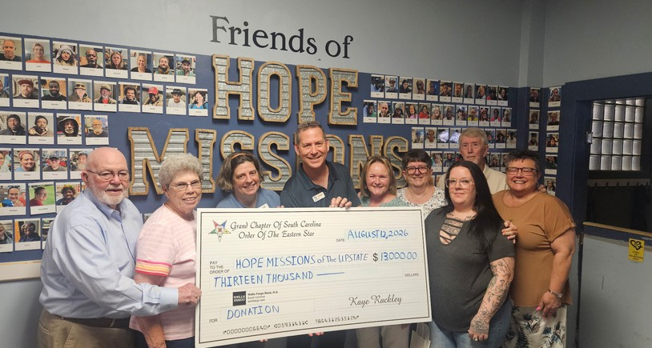
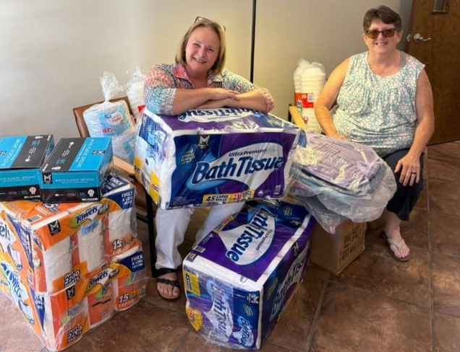
Submitted by
Penny Davis, Chaplain

Calvary Home for Children
Worthy Matron, Tammy Rigsby and Secretary, Awone Rector from Anderson Chapter #130 were blessed to be able to deliver paper products to Calvary Home for Children.
A small gesture but such a big blessing to them. Calvary Home for Children provides Christian homes for all the children in their care.

Summer Bash
Thanks to all that attended the “Summer Bash” Dist 6 Club fundraiser for Anita Dixon, AGC!! Such fun with delicious food, beach music, silent auction, cake auction, door prizes, pretzel jar count & 50/50 raffle. Proud to say it was a HUGE success!
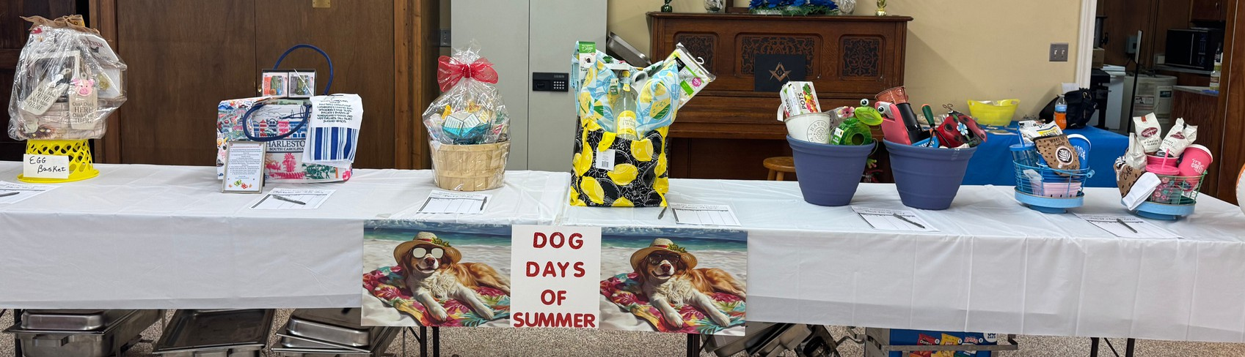
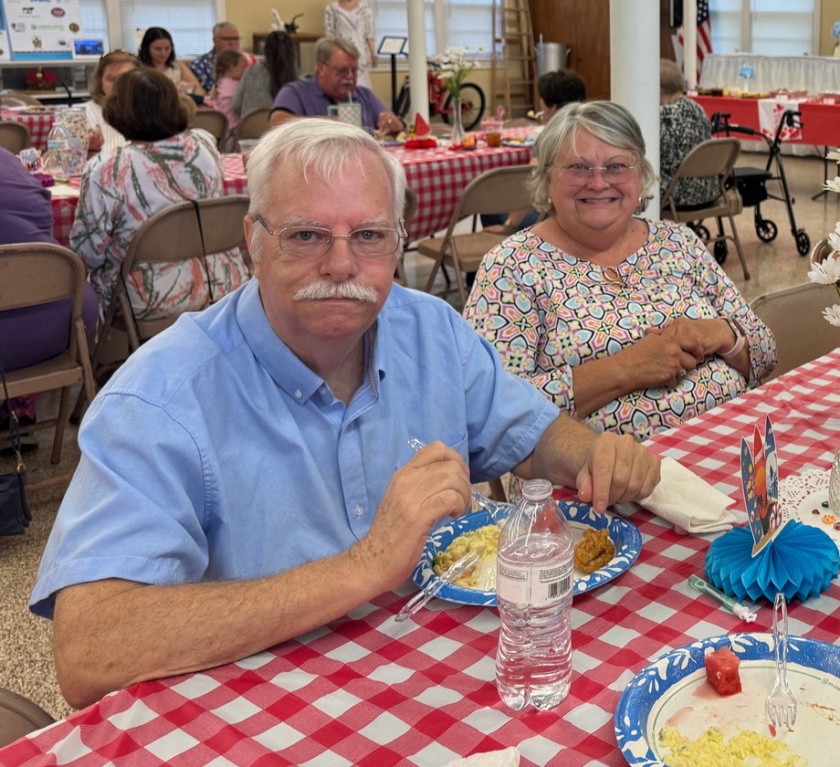
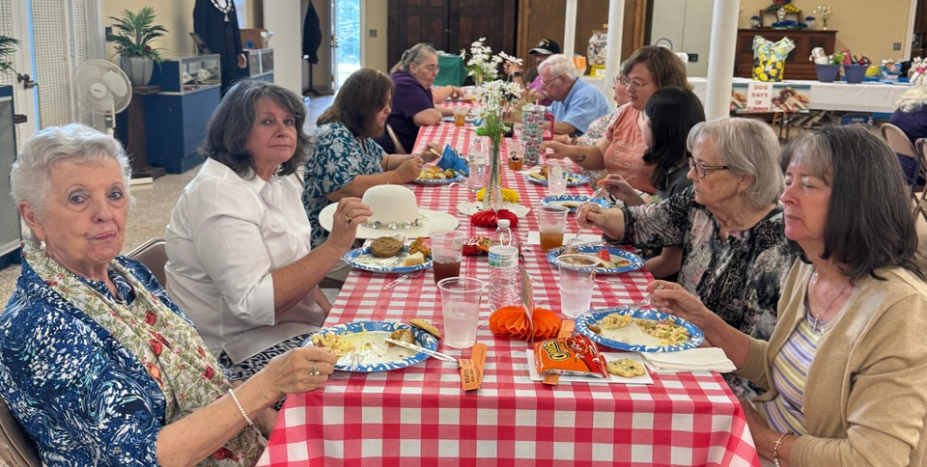
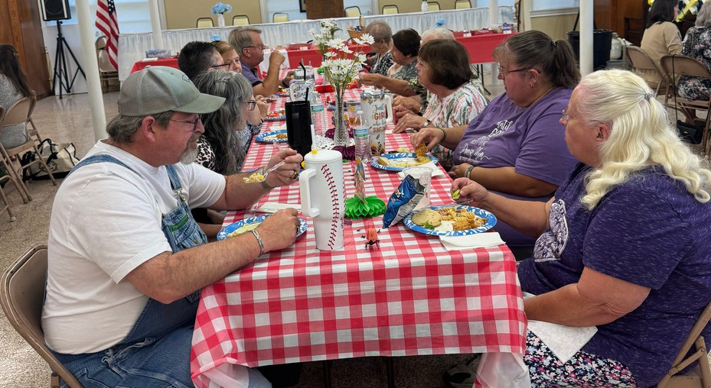
Sherry Jones, Secretary, Dixon #6

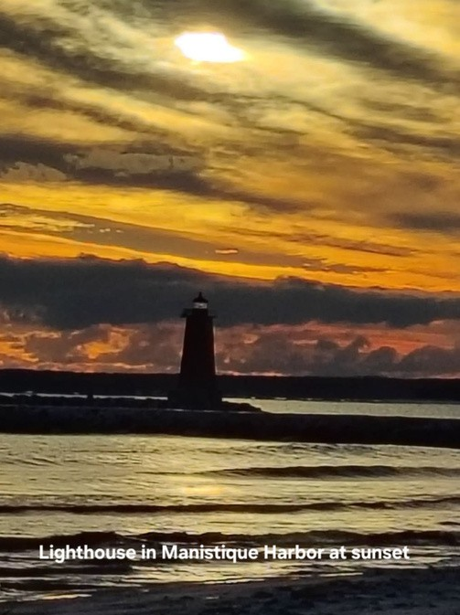
Pictures from SC OES Members
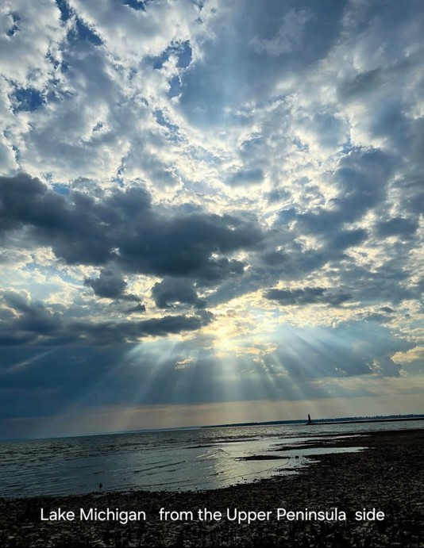

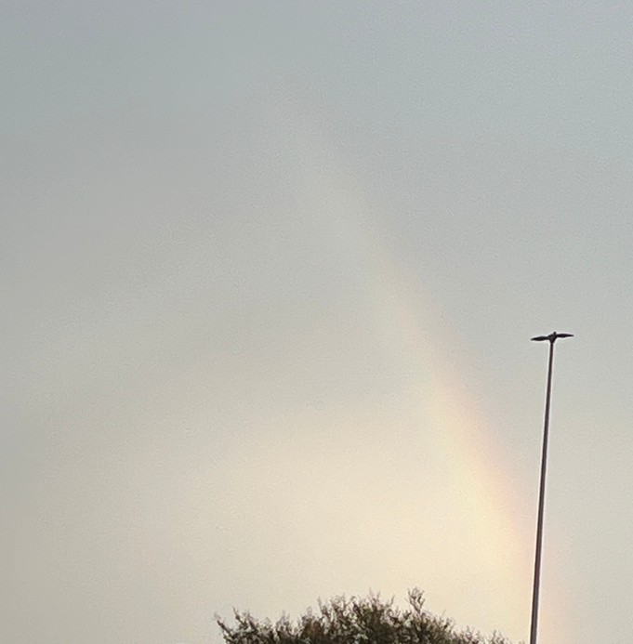

God’s promise to never destroy the world.
This was after a severe flash flood in Charleston/Berkeley County 8/22/26 with over a foot of water in the parking lot and adjacent streets.

mid afternoon sunlit peeking through the clouds the and light house standing guard.



lantana

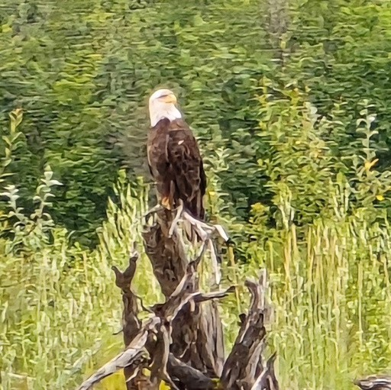
Glacier in Glacier Bay, Alaska Carol Lovece
On the side of the road in Fairbanks Alaska Carol Lovece
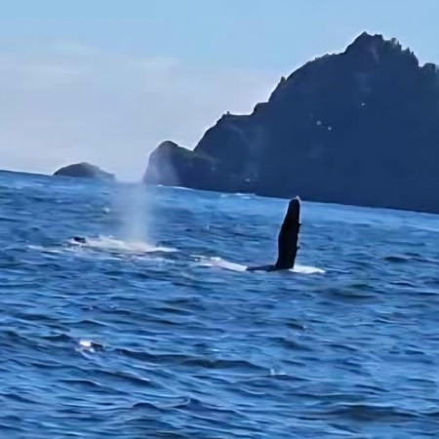
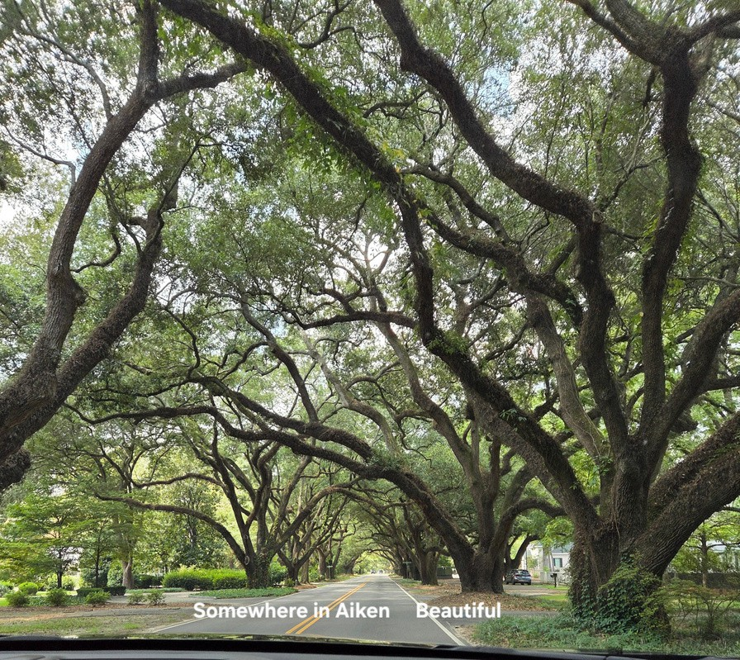
Humpback whale waving hello Carol Lovece

Volume 67 September 2026 Issue 9

Charitable Giving
Page 20

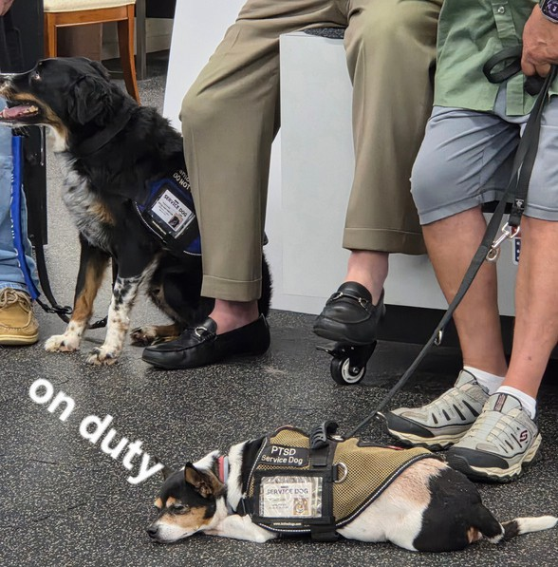
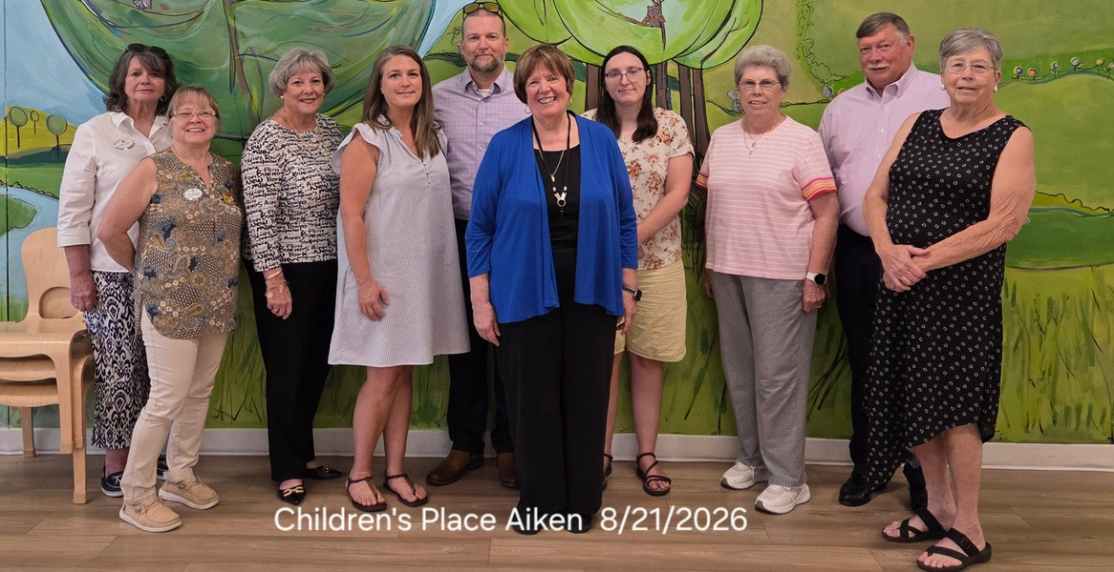
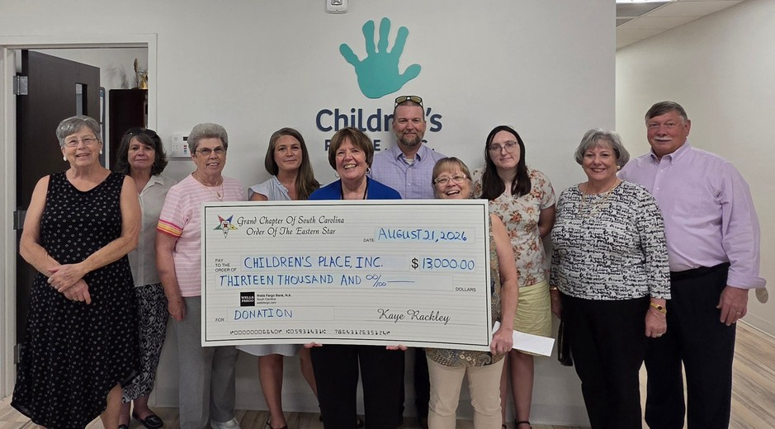

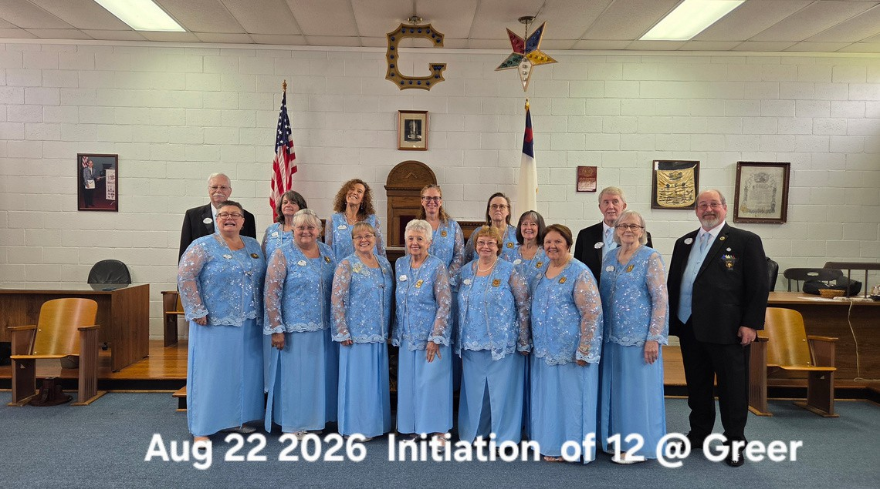
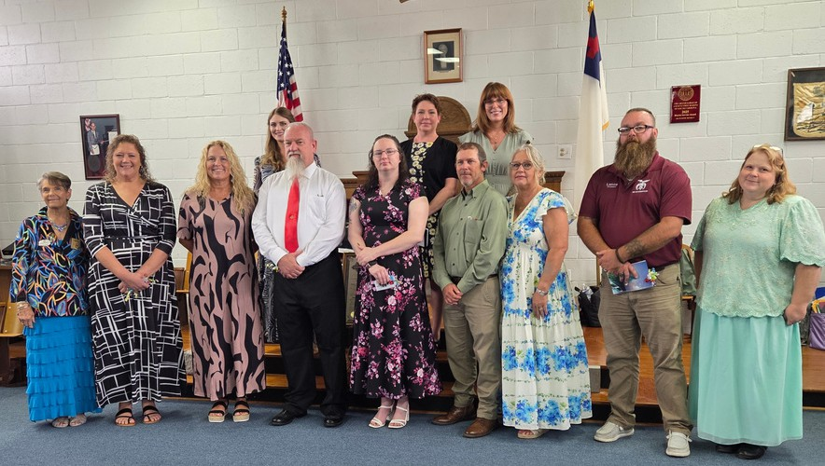
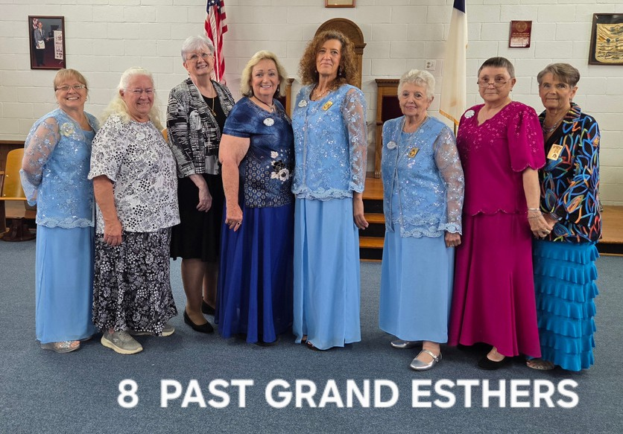
Volume 67 September 2026 Issue 9 Page 21

Palmetto Star News
BULK MAIL US POSTAGE PAID
PERMIT NO. 595 COLUMBIA, SC
Volume 67 September 2026 Issue 9
Page 22

2050 Old Cherokee Road
Lexington, SC 29072

