
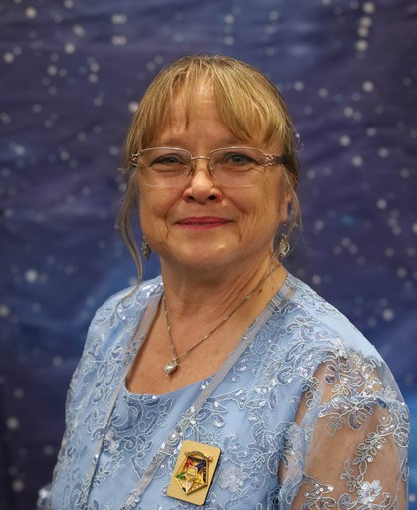

Palmetto Star News
N
A
O
R
D
E
R
o
f
t
h
e
E
A
T
E
R
o
f
S
O
U
T
H
C
A
R
O
L
I
Volume 67 August 2026 Issue 8
S
T
E
R
N
S
D
C
H
A
P

News from the Worthy Grand Matron
T
A
R
G
R
A
N
Hello Sisters and Brothers,
I hope your summer has been full of family and memories, I know mine has. I think it was a little hotter than normal. Of course the 4th was full of family gatherings and we celebrated the 250th birthday of our great nation.
On July 11 our 2nd School of instruction (S.O.I.) was hosted by Greer. It was perfect. There were 5 districts 2-3-4-24 and 15 chapter represented. The
Grand Officers preformed the work and we had 109 members present. So far that is the highest number. The food was great and there was plenty of it. Thanks to the wonderful team of District Deputies who put this all together. July 18 was the 3rd S.O.I. at Berkeley D-18. 1 district and 4 chapters. The fellowship was wonderful, and the food was great. There were 87 members present for the school.
On Sunday, July 19 we had the first line officers for 2026-2027. Large crowd of sisters and brothers. We joined our clubs, shopped at the tables, and ate as much food as possible. We are also starting the Pecan list for purchase. If you are interested please let someone know. More information on cost and delivery in next month’s letter. They are usually delivered in November. Just in time for Christmas presents.
July 22-28 I traveled with the Rainbow Girls to Tucson, AR for the Supreme Assembly which takes place every two years. Our SC Rainbow Girls were invited to perform the Grand Cross of Color at Supreme. They were so excited and did a fantastic job representing SC Rainbow. On Monday, July 27, I was present, along with Glenda Winchester, PMWGM and Jennifer Bailey, GC, to witness our very own Mrs. Dedra Hart, of Hartsville, get installed as The Supreme Mother Advisor of
I.O.R.G. She has been dedicated to the Order all of her life. Her care and concern the young ladies shows in everything she does. Congratulations Sister Dedra! Also Brother George Latta of Dixon Chapter has become the new Supreme Inspector for SC Rainbow. Congratulations to him as well.
Don’t forget to send a picture. My picture this month is a sunset in Jamaica. It is so peaceful to sit and watch the sun go down over the horizon. It signals it time to rest.

Heads up! There will be a special Initiation on August 22. The Grand Officers have been asked to initiate 14 members in one meeting. Lyman has 11 petitions and Greer has 3 petitions. This is something that hasn’t been done in a very long time. Mark your calendars, and come and be a witness.
I look forward to the next 3 schools in August. Please try and make
it to one of them, to refresh your knowledge and rekindle friendships. See Ya on the road. Judy M. Krummich WGM

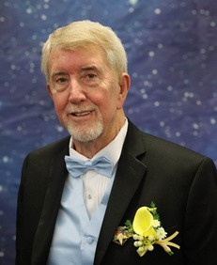
News from the Worthy Grand Patron
Can you believe it has already been a little over a month since Grand Chapter?
First, I want to say thank you to all my sisters and brothers who have entrusted and honored me with the position of WGP of South Carolina OES. It has truly been an honor the past two years and I am looking forward to what this year holds.
After Grand Chapter we had little time to rest. Our first SOI was held in
Dentsville on Saturday. Then it was off to Rainbow Assembly the next Friday. The Rainbow girls are truly amazing in their work. We can all take lessons from them. The next week was July 4th and we all had some rest and family time.
We then headed to Greer for SOI #2. Our Grand Lecturer, Don Cool, is doing a really great job with our instructions. Both schools had 109 in attendance. The SOI #3 was held at Berkley chapter with 87 in attendance. SOI #4 will be at Dixon Chapter in Laurens on Saturday August
1. Make your plans to attend the SOI for your district.
I am looking forward to seeing you as we travel throughout the state this year. Remember to always hear…. Hear His Word, Examine It, Apply It, Respond In Prayer.

Safe travels.



Seneca 5
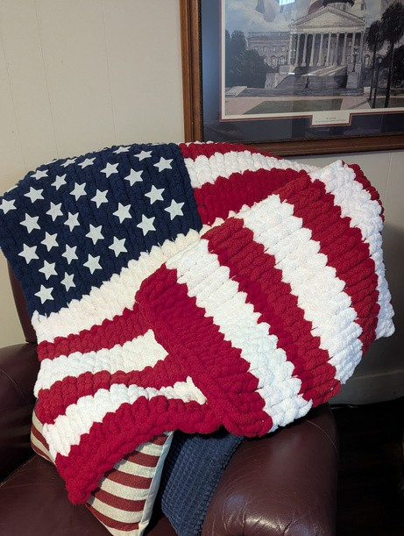
Seneca #5 had their regular stated meeting on July,2026. We enjoyed a delicious meal and wonderful fellowship. Our district deputy, sister Kathy Bailey was with us. We had the chairs full and side liners. It was so wonderful to see this.
Sister Kaye Rackley read the meaning of the Eastern star and some history of Seneca Chapter #5. Yesterday was Seneca's birthday. Sister Dallas Shirley donated this beautiful handmade throw for us to raffle off. Stay tuned for raffle tickets and info as soon as I get approved by the WGM. Our next meeting is August 18, I hope you can visit us. Please keep our sisters and brothers that are traveling in your prayers. Also, we have many that are sick.
Have a blessed day and God bless ya. Star love, Patty Alger, PSN reporter.

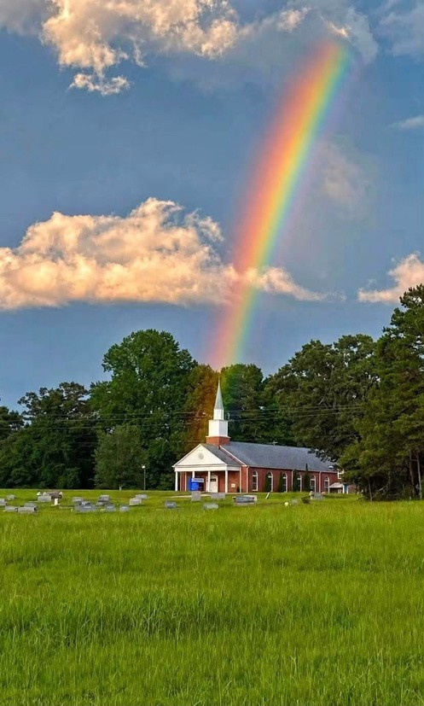
Pictures from SC OES Members

Jamaica Sunset on my 1st visit to the island.

Judy Krummich

Showing God's love. Patty Alger,PSN reporter

Beautiful deer in my yard Holly Storey Schneider, PSN Editor

Easley 200
Greetings from Easley #200! We had a great July meeting. Sister Jeanette did some education regarding the Declaration of Independence, and we all enjoyed the fellowship. We are currently working on our school supply list to help our local elementary school get a good start to the new school year. We had a fundraiser at Panda Express. The fellowship was great, and the food was delicious. Our regular business meetings are on the second Monday of each month. Meal at 6:30
p.m. with our meeting at 7:30 p.m. We would love to see you there! Submitted by: Susan Irby


Anderson 130
Hello from Anderson Chapter #130. We were blessed to have the following visitors join us for a meal, fellowship and our stated meeting: Joy Thibaudeau, Cond Easley #200, Mike Smith, WGP Easley #200, Vickie Graham, AM Westminster #103, Pamela Michalski, Organist Westminster #103, Kathy Bailey, Electa Westminster #103, Candie Perkins, Grand Ruth Liberty #80 and Monaghan #82, Elizabeth Perkins, AC Liberty #89 and Monaghan #82, Dana Graham, Ruth Westminster #103, Elizabeth Marir Easley #200, Connie McDaniel, Chaplain Easley #103.
Anderson #130 welcomes you to our next stated meeting on Tuesday, August 11. Blessings, Penny Davis, Chaplain
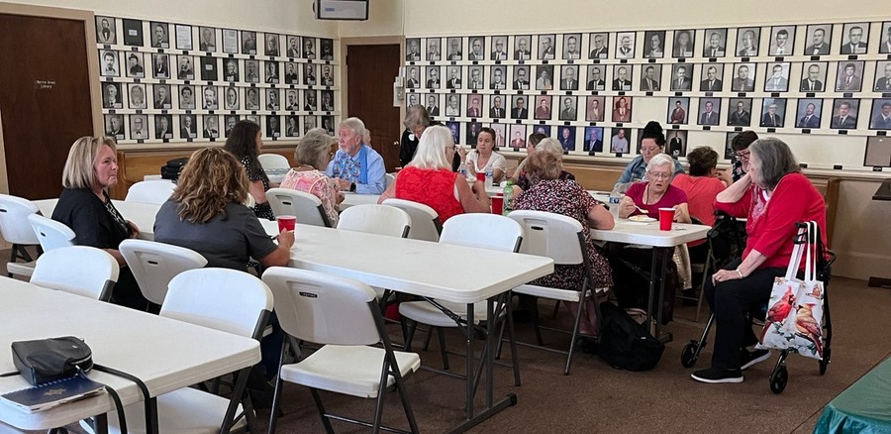

Tallulah 16
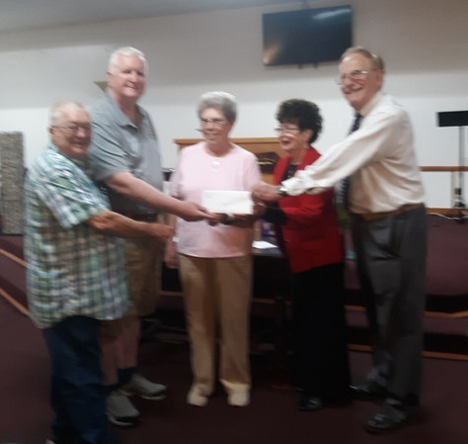
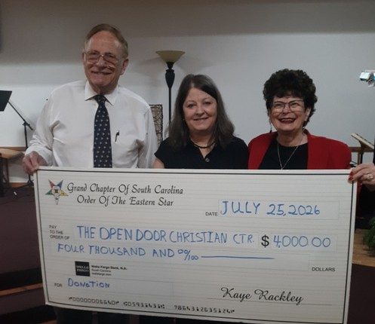
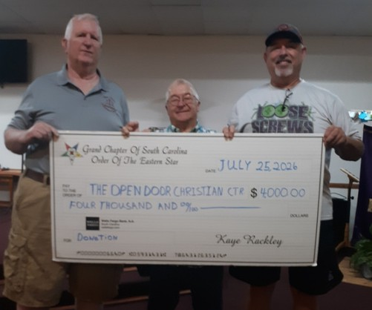
Grand Chapter Order of the Eastern Star Charitable Giving, the Tallulah Chapter 16 Spartanburg, picked their charity for 2026 - The Open Door Christian Center in Clinton with a donation of $4,000.

Pictured to the left: Jimmy Webb, CEO; Michael Campbell, Board Member; Kaye Rackley, Grand Treasurer;
Art Alloy; Past Worthy Patron, Patricia Alloy, Past Worthy Matron; Elke Lester, Worthy Matron; and Barbara Sanford, Secretary

Pictured to the right: Art Alloy, PP;
Elke Lester, WM; Pat Alloy, PM

Pictured to the left: Jimmy Webb, CEO;
Michael Campbell, Board Member



Contact Toni Clark 864-787-5681

Westminster Chapter #103
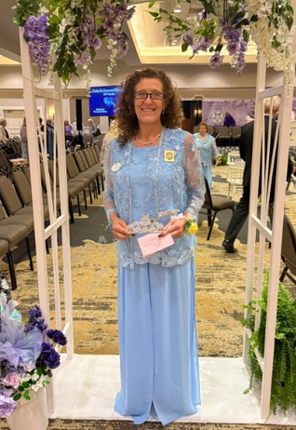
Greetings sisters and brothers,
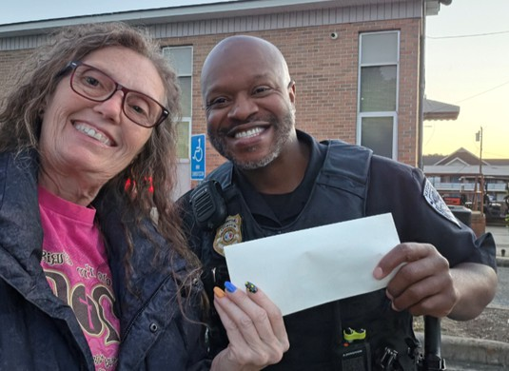
For the month of May the chapter made a monetary donation to the Westminster Police Department as a sponsor for the Inaugural Westminster Police Department Foundation 5K which was held on May 16. The check was presented to Ike Lewis by Darlene Butts.

The June meeting was moved to June 25 due to Grand Officers being installed in Columbia.
Several members attended and our Worthy Matron – Mychele Christmas was installed as Grand Esther.
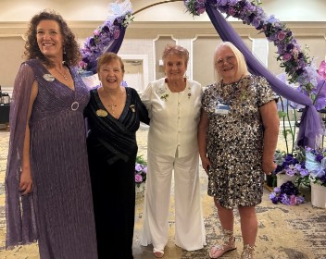
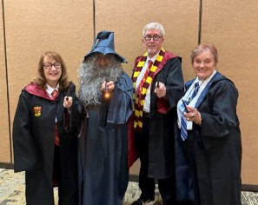
During the June meeting WM Mychele announced this year’s committees and her watchword which is “DOG” Depend On God. Her special project for this year is to help with the Oconee Animal Shelter. A monetary donation was made as well as needed items throughout this year of food, towels, blankets, bleach and other items that pertain to dogs.

Westminster Chapter #103
At our July meeting we enjoyed grilled hamburgers, baked beans, chips, veggies and desserts. Vickie Graham presented something to correlate to Independence Day and she chose The American’s Creed shown below. It was very informative and we enjoyed it.
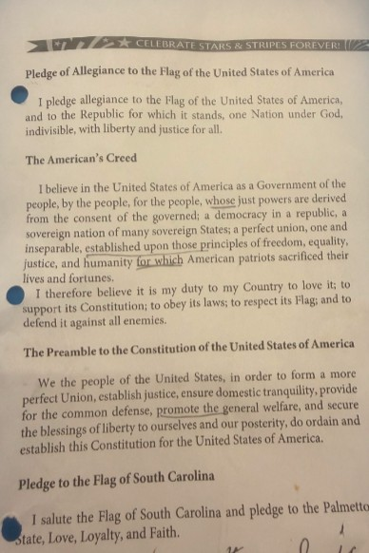

We made a monetary donation to Sister Mandy whom is a local school teacher for needed school supplies. Our WM Mychele was very sick and had to miss the meeting and was taken to the ER for treatment. She is still very weak and in need of prayers. Several names were mentioned on the prayer list. Our Chapter is still growing, and we invite you to attend our meeting on the third Thursday of the month.
With Star Love,
Darlene Butts Chapter Reporter


You are cordially invited to attend The School of Instruction #5 Hosted by Districts #13 and #15
Charleston County Masonic Association 1285 Orange Grove Road
Charleston, SC 29407
Saturday, August 8, 2026

- a.m. School Begins
- noon Lunch provided by Districts #13 and #15 1 p.m. School Resumes


Sister Judy Krummich, Worthy Grand Matron Brother Mike Smith, Worthy Grand Patron Brother Don Cool, PGP, Grand Lecturer
Sister Angie Owens, District Deputy of District #13 Sister Jean McMillan, District Deputy of District #15
Sister Heather Kamphaus, Deputy Grand Marshall to WGM Sister Durena Marcum, Deputy Grand Marshall to DD #13 Sister Susan Brady, Deputy Grand Marshall to DD #15 Brother Whitey Hamilton, Deputy Grand Marshall to WGP

Lillie Chapter #27
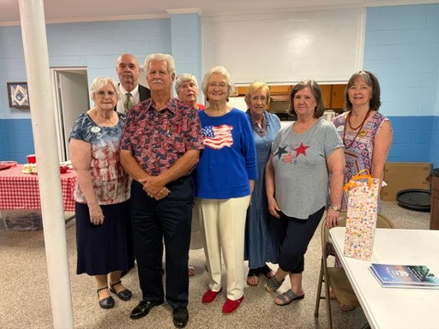
3
2
1

Lillie Chapter#27 had a few folks in Red, White and Blue at their July meeting. Worthy Matron Durena Marcum awarded prizes!
From the left:
3rd place Kathy Ahner, John L Flynn Chapter; 2nd place WP Neil Miles
1st place AM Edna Horne

Lexington Chapter #176
Just a picture from the Lexington Chapter # 176 with another load of wish list items for PAALS. Sister Cindy wants to thank the following ladies for their generous donations, Sisters Jan Thomason, Pat Gulledge, Alice Koontz , Shirley Martin and Cindy Leitner. Sister
Cindy delivered to PAALS on Monday, June 20, 2026 and Mrs Liz and Mrs Edith were humbled to say the least. Thanks to Lexington Chapter for their continued support.
Cindy Leitner, PM, Grand Chapter Service Dog Committee member
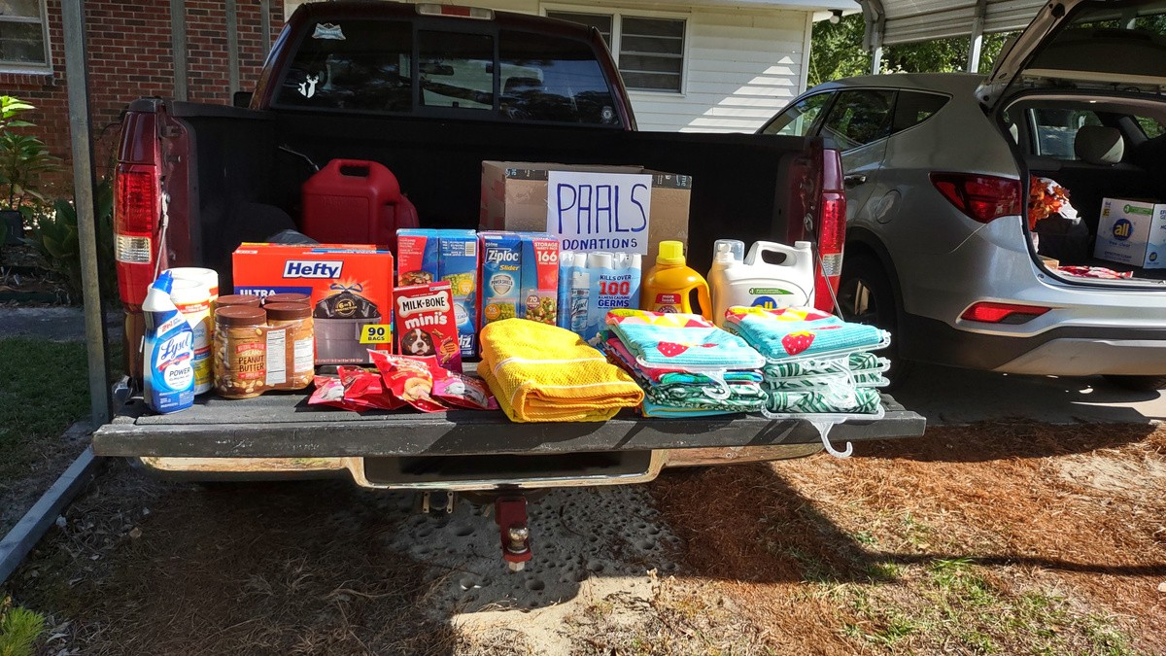


ITINERARY CHANGES
Greer O.V. has been reschedules from Oct. 8 to Feb 11, 2027

Reidville/Glendale will have combined O.V. on Friday November 20, IGO WGM remove Reidville 1-23-27, page 78 and Glendale 10-12 page 75.

Nell O.V. has been rescheduled from 1-16-2027 to Sept. 5th, IGO WGM Nell meets on on the 1st Thursday page 64 NOT first Monday

In Memoriam
Please keep the family and friends of these Eastern Stars in your prayers: Maria Gillespie, Liberty Chapter
Myra Alley, Roebuck Chapter

Grand Chapter of South Carolina 2026
By Robyn Pewitt, Grand Representative of South Carolina in California (2025–2027)
The Grand Chapter of South Carolina held its "United in Love and Harmony" Grand Chapter Session from June 13–17 2026, in Columbia, South Carolina, under the leadership of Worthy Grand Matron Sheila Jackson and Worthy Grand Patron Steve Jackson.
The week began on Saturday, June 13, with a fun-filled competition between Harry Potter (the Worthy Grand Matron's team) and Star Wars (the Worthy Grand Patron's team). The evening was filled with laughter, friendly competition, and entertainment, including an Elvis impersonator who was a member of the Order. It was an exciting and memorable way to begin the Grand Chapter Session.
On Sunday, June 14, we attended the Grand Representatives Luncheon, where past and present Grand Representatives gathered to enjoy fellowship and renew friendships. That evening, we had the pleasure of attending the Formal All Members Banquet, where we were treated to another outstanding evening of entertainment.
Monday, June 15, began with the Informal Opening of Grand Chapter following lunch. During the session, Community Liaisons, representatives from other fraternal organizations, and charity spokespersons were introduced. The afternoon also included the Necrology and Memorial Service, a beautiful and meaningful tribute honoring members who had passed away. The evening session continued with the introduction of distinguished guests, including the Most Worthy Grand Matron and Past Most Worthy Grand Matron and many beloved Past Grand Matrons and Patrons.
On Tuesday, June 16, the Formal Opening of Grand Chapter was held, followed by the afternoon business session. That evening, members gathered for the All Members Reception, a casual event held to thank everyone for their support of the Worthy Grand Matron and Worthy Grand Patron throughout the year. It provided an excellent opportunity for fellowship and friendship. Wednesday, June 17, began with the election of Grand Officers and the completion of the remaining business of Grand Chapter. The session concluded with the Retiring of the Jewels.
That evening, the Installation of the 2026–2027 Grand Officers was held, bringing another successful Grand Chapter Session to a close.
It was truly a pleasure to meet my counterpart and the many members who warmly welcomed my family and me throughout the week. Their kindness and hospitality made us feel like part of their family from the moment we arrived.
One interesting difference between the Grand Chapters of South Carolina and California is found in the ritualistic opening. Because South Carolina has individuals operating the sound equipment during the sessions, they use a shortened form of the opening ritual rather than the full ritualistic opening. Another distinction is that each District Deputy Grand Matron is assisted by a Deputy Grand Marshal, who serves as a backup whenever assistance is needed.
Additionally, the Grand Sentinel, is elected to progress to the office of Associate Grand Patron, a tradition that differes from California‘s line of advancement.

Palmetto Star News
2050 Old Cherokee Road
Lexington, SC 29072
BULK MAIL
US POSTAGE
PAID
PERMIT NO. 595
COLUMBIA, SC
Attending the Grand Chapter of South Carolina was a wonderful experience. I greatly appreciated the opportunity to represent California, strengthen the bond between our two jurisdictions, and experience the traditions and warm hospitality of South Carolina. I am grateful for the friendships that were made and look forward to continuing to represent our Grand Chapter throughout the remainder of my term while strengthening the relationship between our two jurisdictions.



