

Palmetto Star News
N
A
O
R
D
E
R
o
f
t
h
e
E
A
T
E
R
o
f
S
O
U
T
H
C
A
R
O
L
I
Volume 67 July 2026 Issue 7
S
T
E
R
N
S
T
A
R
A
N
D
C
H
A
P

2026-2027 Grand Family
G
R
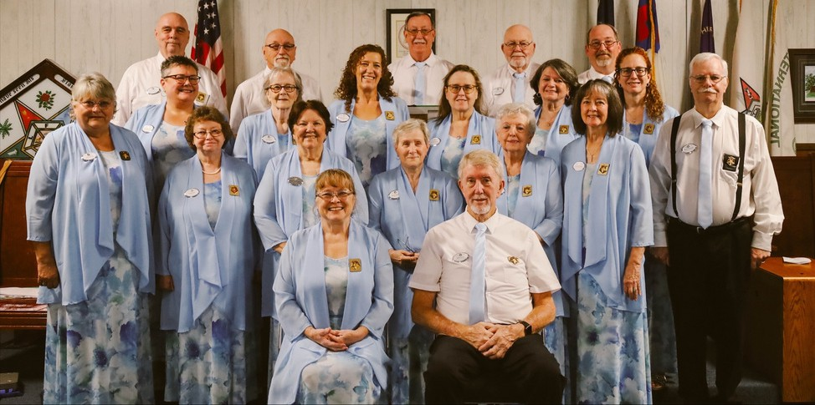

Worthy Grand Matron - Judy Krummich Worthy Grand Patron - Mike Smith Associate Grand Matron - Anita Dixon Associate Grand Patron - Mark O'Shields
Grand Secretary - Sarah Jane Schrodetzki, PGM Grand Treasurer - Kaye Rackley, PGM
Grand Conductress - Jennifer Bailey Associate Grand Conductress - Kim Derosiers Grand Trustee, CH - Fred Armstrong, PGP Grand Trustee - Lynette Jenkins
Grand Trustee - Josiane Horton
Grand Chaplain - Tony Lowder Grand Lecturer - Don Cool, PGP Grand Marshal - Marie Caddell Grand Organist - Angela Livingston Grand Adah - Trish Latta
Grand Ruth - Candie Perkins Grand Esther - Mychele Christmas Grand Martha - Judy Boykin Grand Electa - Tonda Giles
Grand Warder - Ricky Doby Grand Sentinel - Donald Owens

Assisted Care Board Bobbie Kinard - 3 years
Charlene Sena, PGM - 3 years Paula Still - 2 years

News from the Worthy Grand Matron
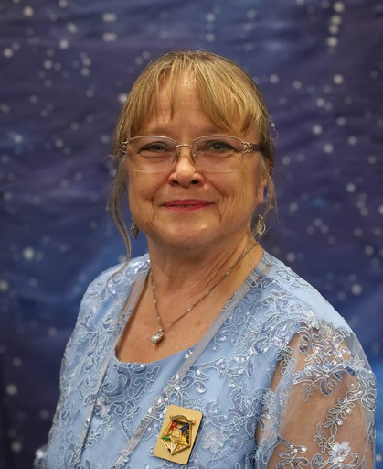
Hello my Sisters and Brothers
Our “Look to The Stars” year has begun. The Grand Officers were installed on June 17 at the Double Tree on Bush River Rd here in Columbia. It is truly an Honor to serve this Great State of South Carolina, Order of the Eastern Star. Our new core of Officers are excited to get on the road and visit every corner of this State.
My humble thanks go out to my Installing Officers. Glenda Winchester PMWGM as our Installing Grand Officer. Assisted by Thelma Gaines, PGM,
Donna Brantzeg PGM, Lynda Pittman PGM, Nancy Jones PGM, Kathy Wallace PM and Joy Thibedeau PM for your outstanding team work and floor work. Judy Justice for music which fills my soul, and Bros Larry Brantzeg PGP, and George Mabry PM.
The star point and emblem presentation was solemn and perfect. And the Bible Presentation was given by my Grand-daughter Kirsten Kamphaus who was the Grand Worthy Advisor of the International Order of Rainbow for Girls. It was all absolutely beautiful. Thank you.
The Grand session of “United in Love and Harmony” was a fun year. Full of Laughs, learning and trips on the road, with light sabers and wands flying all over the place. Thanks to Sheila and Steve Jackson for your great leadership, and a successful year.
The Itineraries are out. Please see you District Deputy for a copy. They are $4 each this year. Our Theme for our session is “Look to the Stars.” I am an avid Star and night sky watcher. I have been since I was 6 years old. My aim is to Recycle, Reuse, and Repurpose. All of our chapter have Decorations that have been stored form one year to the next. Be creative. Pull them out and see how they can be used again for a school or Official visit. Use paper products that can be recycled and that can decompose. Try not to use Styrofoam, it is not good for the planet. Or even regular dishes and silverware that can be washed and reused again. It is the small things that can save you money. One person can make a difference.
My watch word is GRACE (Grant Respect and Compassion Everyday.) You never know what a person is going through so let’s always try to show Grace. My Emblems are The Tiger. The largest of the cat feline kingdom and endangered due to hunting by man and human interference to their habitat. Not to mention how beautiful and powerful they are. And the Sun and Moon. My fun symbol is TIGGER from Winnie the Pooh. He is always upbeat, and full of energy and FUN.
Now I have a fun task for the membership of South Carolina Order of the Eastern Star. Because we live in a world with such natural beauty. I would like to ask you to take a picture if you are out in nature or on a vacation and you see a site that takes your breath away. Send the picture to the PSN and put a brief comment with it of how you felt, and why it moved you. It can be anything.
Landscapes, birds, animals, ocean front sunsets and sunrises. Our PSN Editor has said that they can be put in the paper. And next June at Grand Chapter my hope is that all the photos that were sent in will be displayed on the big screens as we wait for our meetings to start. And to display our Beautiful planet.

The first School of Instruction (S.O.I.) took place at Dentsville Lodge the 3 days after the session ended. We had 5 districts 15 chapters within the districts, and a grand total of 107 members present. WOW what a great turnout. There was plenty of food and plenty of seats, and lots of hugs to go around. Great Job to the Grand Officers. Job well done. The first school is always the most scarry. We have 5 more schools to perform. Find one close to you and attend.

On June 26, The Grand Officers attended “A Journey Within” Session for the International Order of the Rainbow for Girls at the Scottish Rite Temple on Garners Ferry Rd. Sister Kirsten Kamphaus Grand Worthy Advisor presiding. Along with Sis Dedra Hart Supreme Worthy Associate Advisor, and Supreme Inspector. This was the first time that, this years’ Grand Officers were introduced. We were very impressed with the ritual work and floor work from these young ladies. Some of these ladies will be traveling to Tucson Arizona in July to perform the Grand Cross of Color for the Supreme Assembly. Quite an Honor. We wish them safe travels and wonderful memories.
Finally, I hope to see you on the road real soon. And remember to Look to the stars…. Great things are coming.
Star Love, Judy M. Krummich WGM

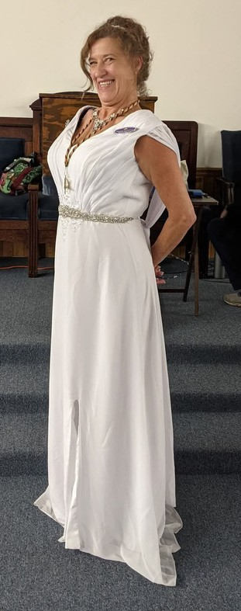
Congratulations to sister Mychele Christmas
on her appointment to Grand Esther 2026-2027.
We love you
and are so proud of you.
Star love,
Patty Alger, WM and members of Seneca #5

Anderson 130
Greetings from Anderson 130. We gathered at 6:30 p.m. for fellowship and a delicious light dinner before our regular stated meeting on May 12. We were pleased to have Candi Perkins, WM Liberty at our meeting.
A vote was taken and approved to donate our April, May and June sunshine funds to purchase items for The Calvery Home for Children.
You are welcome to visit us at our next stated meeting.
Blessings,
Penny Davis Chaplain

Easley 200
Greetings From Easley #200 Order of the Eastern Star! We started our 2026-2027 year with good fellowship and lots of smiles before our meeting. Liz Marion won our "May Flower" drawing held at our meal. We had a great meeting and plan to install a new member at our next business meeting.
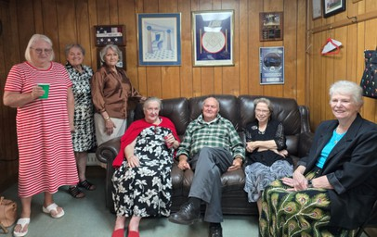
We will start back our monthly fellowship meals on the 4th Tuesday of each month at 6:30 p.m. The location may change monthly. We are looking forward to collecting school supplies for a local elementary school for the third consecutive year. We will also continue working with Meals on Wheels. If anyone would like to be involved in that, just let us know! You can reach out to us at oeseasleysc@gmail.com. Please join us at our meeting on the second Tuesday of each month at Bates Lodge in Easley. We would love to see you there.
Submitted by: Susan Irby
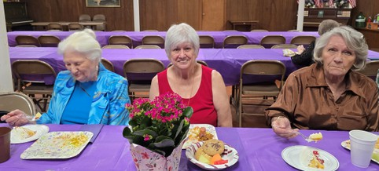

Dixon 6
Dixon Chapter #6 proudly welcomes three new members, Tierah Ebert, Mckenzie Flad & George Latta, Jr. The Initiation was held in June 9 on our regular meeting night. We would like to extend a huge Thank You to all our Protems for their wonderful work to bring in these new members, especially our WGM, Sheila Jackson that performed the part of the WM. Blessings abound as our Chapter grows!!
Submitted by Sherry Jones, PM, Secretary
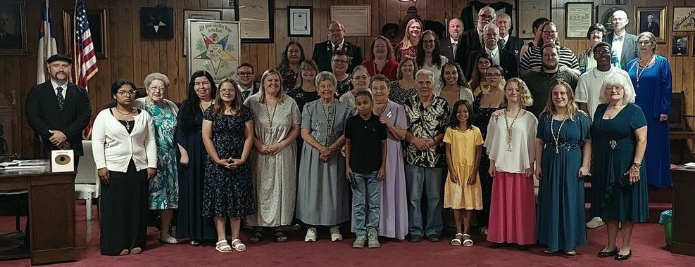

Seneca 5
Seneca #5 had an initiation on Friday May 15, 2026 for Miss Elizabeth Lowman. It was a beautiful initiation and she was such a beautiful candidate. Beth was so happy to have sisters and brothers, and she was very impressed with the initiation. She just loved our star point lectures. I know she will be an asset to our beautiful order. She will be having some surgery soon so please keep her in your prayers.
We had our regular stated meeting on Tuesday the 19. We enjoyed a delicious meal and Crystal and Summer and Wafer from First Light in Walhalla joined us for dinner. Afterwards, they told us about First Light and what they do. They work with children and adults of physical abuse and sexual abuse. They assist with counseling and safe placement. They also assist with clothes and children's needs. We donated diapers, clothes, cleaning products, water, blankets, toys and individual packed snacks for the kids. Wafer is a emotional support dog that helps calm the Children. We ended their visit with the donations we collected and gift cards. They were so happy to receive the donations. This will be an ongoing charity for us so if you wanna join in, we welcome you. We had a good and productive meeting. We are selling t- shirts with COFFEE on them. It stands for Christ Offers Forgiveness For Everyone Everywhere. All proceeds go to the chapter. If interested, please let me know. Grand chapter is soon, hope
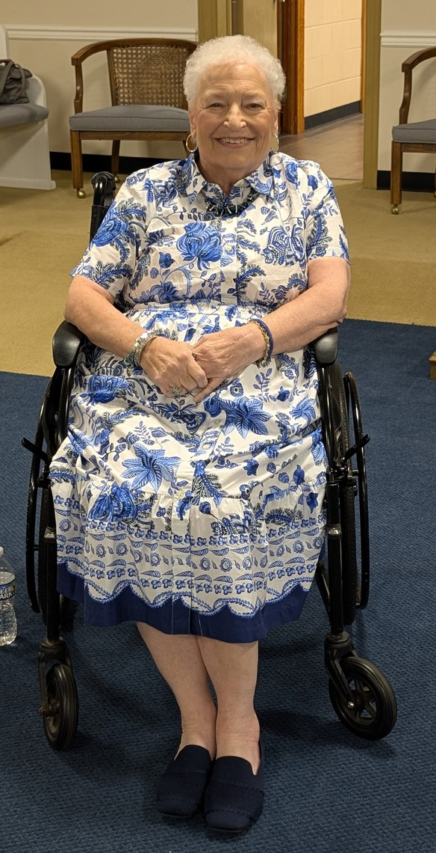
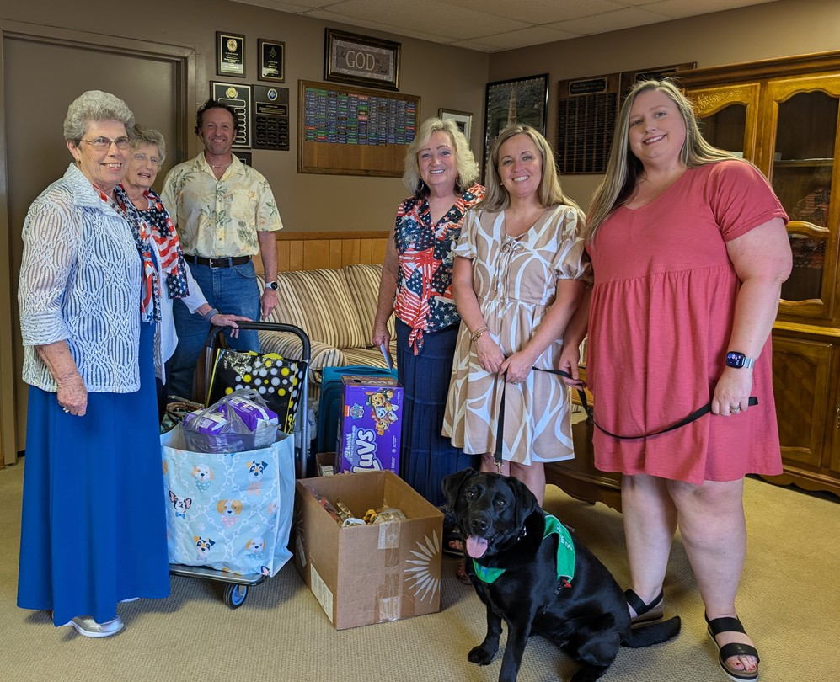
to see you all there. Prayers for safe travels for all. Star love, Patty Alger PSN reporter

Carolina #25!! Hi everyone, hope each of you have a blessed day!! We have been so busy, in the last couple of months with installations, a fundraiser, and the trip to the Ark Encounter!! As I mentioned each month we try to support our sister chapters, in anyway we can!! Especially with the Installation of Officers, in or by April. Trying to help ,in making their installation as memorable, as possible.
The Ark Encounter and Creation Museum, there are no words really to describe what you see and learn. Breathe taking would come close. And the more you take time to really, look at the displays and read, the more you learn and understand, a lot of your who, what, when!! Questions!! If you weren’t able, to go on the tour, with the WGM and WGP, I would encourage you, to try to make plans in the future, to go. You will be so blessed!!!!!
Our fundraiser, was a beautiful quilt donated by Sister Dianna Grant, PM, of Carolina #25, and made by her dear friend Carmen. There is a picture of the winner receiving this beautiful, gorgeous quilt, the winner was Brother Mike Harris of Jacksonboro Lodge, in Ravenel, SC.
We would like to take the opportunity, to thank each, and everyone, in our district and other districts, and the state who supported us. It helped by making our fundraiser, a huge success!!! Also, in March, we were honored by having Sister Carolyn Snelson, PM, become a Grand Representative of Nova Scotia and Prince Edward Island in South Carolina.
Then on our big night, April 28, 3026, we were so proud to install 11 officers, for the ensuing year of 2026-2027. Our Worthy Matron will be Sister Erma Burke, PM, of Carolina #25. WOW!!! What a busy two months. But, we have certainly enjoyed every moment. It’s always a joy to help others, including our sister chapters or someone who needs a help and hand. May God bless you and we hope you can come and visit with us at Carolina #25. We promise you good fellowship and an amazing dinner!! Be safe, be careful!!!
Star Love, from all our members, and our wonderful pro-tems!!!!!!!♥Carolina #25
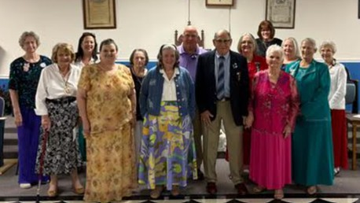
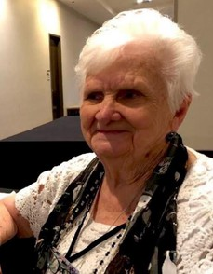
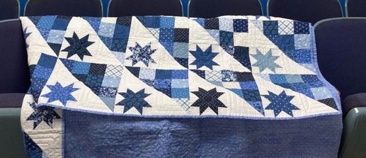

Hi Sisters and Brothers!!? We hope you are doing well and anxiously preparing, for Grand Chapter, in Columbia, SC. At our June meeting, we were so delighted, to have Alice and Ned Vendrick, to join our Chapter, as dual members. And we had the privilege of honoring our Veterans, Masons and Fathers(Dad)!!!! We had a great time celebrating and fellowshipping and of course enjoying great food. We were also happy, to present to our Masons, who have a fundraiser, in progress ,to raise much needed school supplies, for one of the schools, in our community, of Ravenel, SC, with supplies donated by our chapter and a love donation, to help them, in their efforts to help these children, to be prepared, for the school year of 2026-2027.
We also will be going in the dark, for July and August. However, we hope to see you at one of the Schools of Instruction!! Again we would like to thank each of you, for your support in our beautiful quilt fundraiser!!! It was indeed a tremendous success, all because of you!!!! When we return in September, from summer break, we would like to invite each of you to come and spend an evening, with us. I guarantee you will enjoy a great dinner, lots of hugs and great fellowship!!!! Looking (👀) to seeing you, as we visit and travel!! AND AS ALWAYS!! We would love to see you at Carolina #25!!
Star love from all of us at Carolina #25 - Carolyn Snelson, PSN Chapter Reporter

Special items carried to PAALS from Lexington Chapter #176
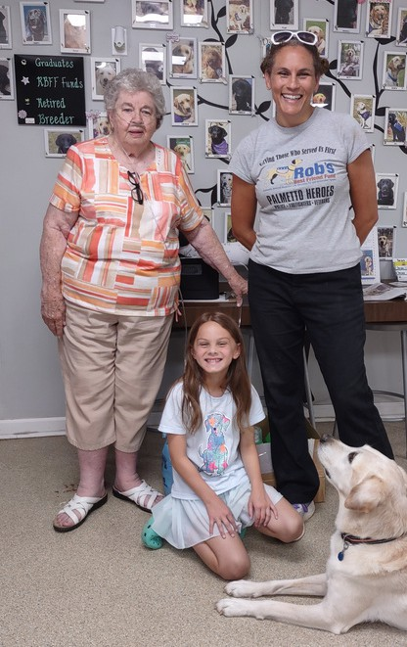
Cynthia Leitner, PM and Brianna and Addie Harrison (Cynthia’s granddaughter and great-granddaughter) collected several items needed for the PAALS program and delivered them. Willis Jenkins also helped with the item collection - including laundry detergent, softener, pooper scoopers, and blankets.
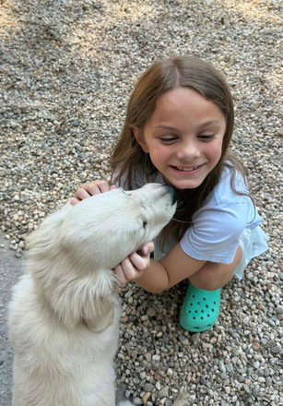
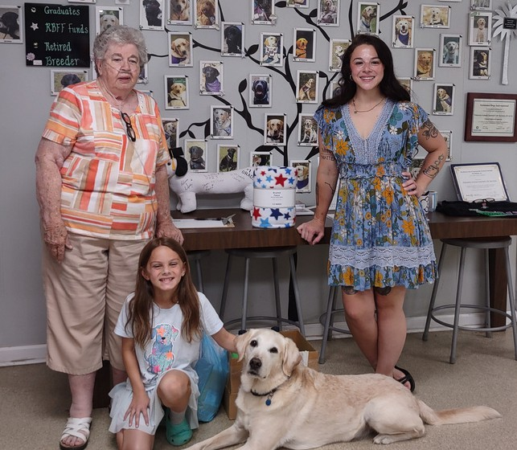

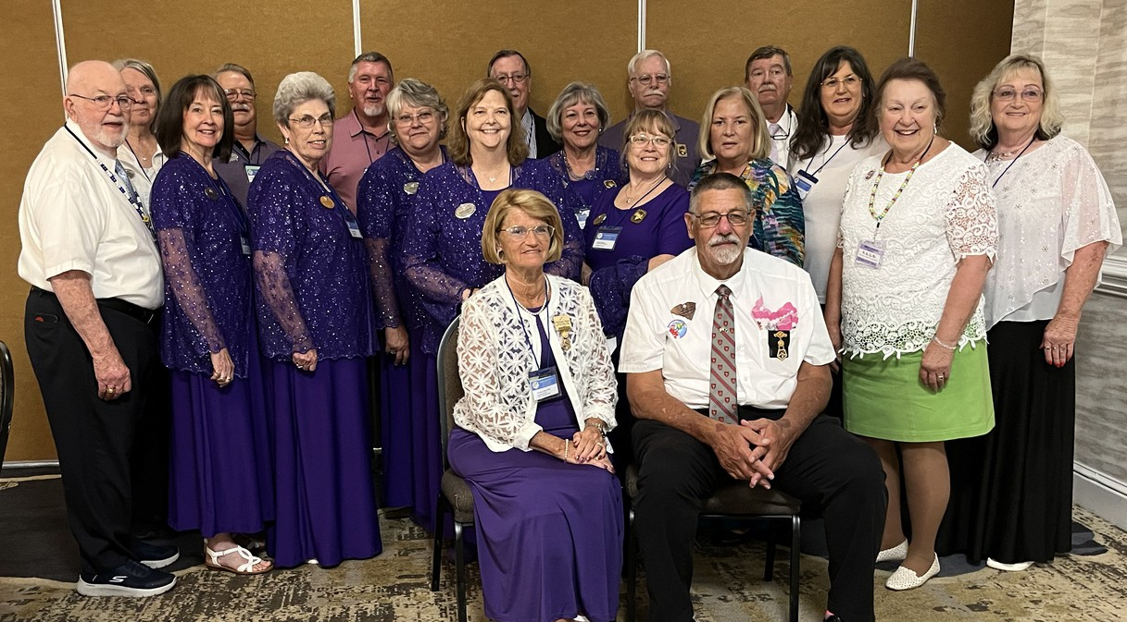
Sena/Collins Grand Family at 2026 Grand Chapter

Grand Officers at Dentsville Chapter for the first School of Instruction
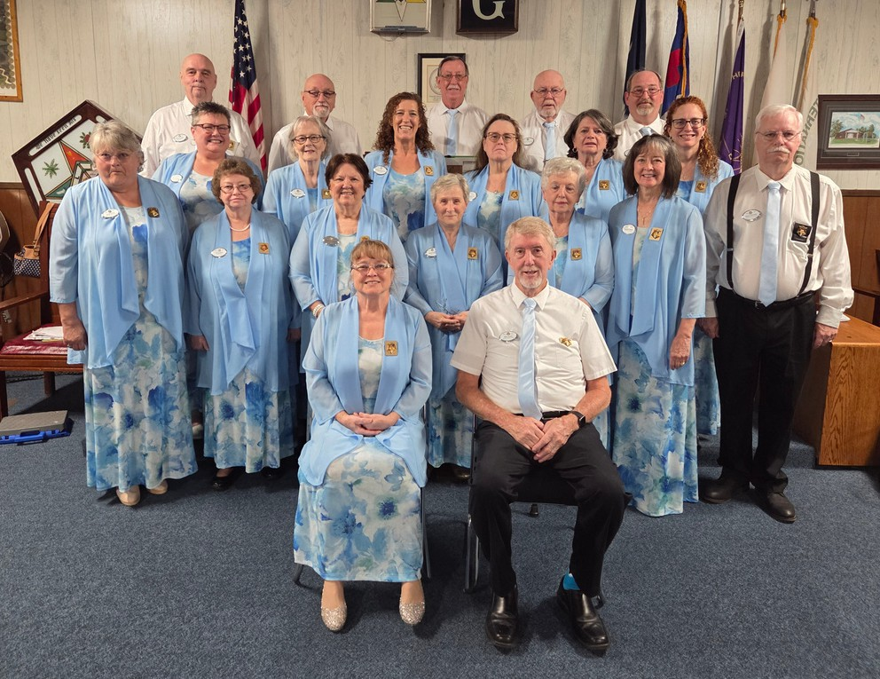

2nd School in Greer. Fantastic turnout. Over 100 members.
Super great time. Thanks for your support.
Judy Krummich and Mike Smith
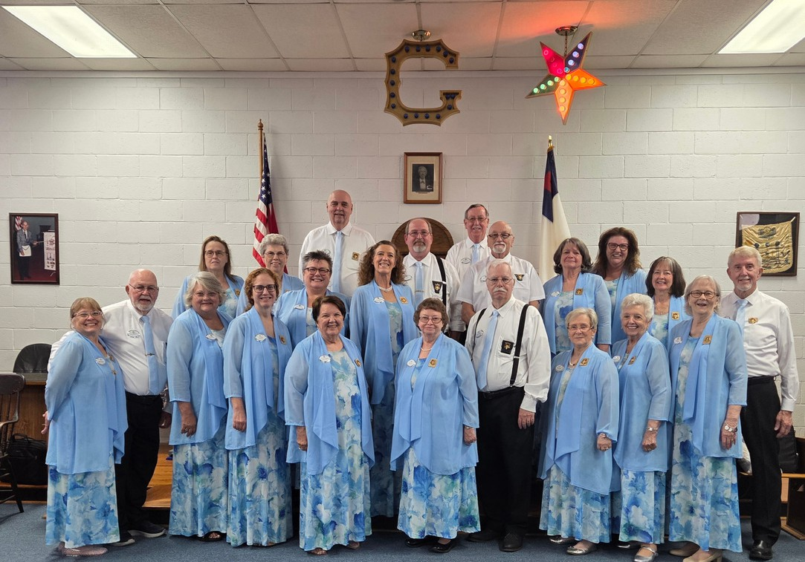


For anyone wishing to purchase photos from Grand Chapter, they are now available: Packages available are as follows:
Portraits/headshots. $25 All social events. $75
All pictures from all events. $125
Please email your request with all details to shutterbugphotography2025@gmail.com. Payment and delivery of photos will be scheduled once your order has been received.
For those who already paid, your photos have already been mailed. For those who requested photos, you were sent an email. If you don’t see it, check your spam/junk folders. If you didn’t get an email at all, please reach out to shutterbugphotography2025@gmail.com



You are invited to attend the District 18
School of Instruction Saturday July 18, 2026
Berkeley Chapter #112
301 California Avenue Moncks Corner, SC 29461
Instruction begins at 11:00 A.M. Break for Lunch at Noon Instruction Resumes at 1:00 P.M.
Worthy Grand Matron, Judy Krummich Worthy Grand Patron, Mike Smith
Grand Lecturer, Don Cool, PGP District Deputy, District 18, Nancy Svagerko
District Grand Marshal, Barbara Collins
You are cordially invited to attend the School of Instruction for
Districts #2, #3, #4 and #24
Saturday, July 11, 2026 @ 11:00 am Greer Masonic Lodge # 151
701 W. Wade Hampton Blvd.
Greer, SC 29650
Worthy Grand Matron, Judy Krummich Worthy Grand Patron, Mike Smith Grand Lecturer, Don Cool, PGP
District Deputy #2, Kathy Bailey Elizabeth Marion, DGM
District Deputy #3, Ginny Medlin Merle Blevins, DGM
District Deputy #4, Courtney Capell Crissie McSwain, DGM
District Deputy # 24, Claudia Seay Dawn Everett, DGM


School Of Instruction Time Correction CORRECT EMAIL ADDRESS FOR CYNTHIA
(CYNDI) LEITNER TO THE FOLLOWING:

The Schools of Instruction will begin at 11:00.
The Grand Officers will meet at 10:00.
Lunch will be served at Noon and Instruction will resume at 1:00.
Please make the correction to your itinerary which has the SOI starting at 10:00.
cmleitner43@gmail.com

Page 7: Worthy Grand Patron Add: Personal Grand Aide Charles Lott
ITINERARY CHANGES
Page 47: Assisted Care Board Delete: Josiane Horton
Add: Bobbie Kinard, PM, 3 yrs, See Pg 24

646 Jackson Street, Barnwell, SC 29812
803-300-0740
Harmony Hope #229, D-9
Page 11: Grand Treasurer Add: Kaye Rackley, PGM
145 Shadowood Ct, Seneca, SC 29678
864-710-8789
Seneca #5, D-2 DOB: 12/06
Escort:
Page 13: Associate Grand Conductress Add: Kim Desrosiers
3127 West Chester School Rd, Chester, SC 29706 803-385-7923 (c)
rdesrosiers@truvista.net Richburg #213 D-8 DOB: 07/04
Escort:
Page 16: Grand Trustee Add: Josiane Horton
161 Meadow Wood Dr., Lexington, SC 29073 803-315-2555
jhorton7@sc.rr.com Lexington #176, D-22 DOB: 08/01
Escort:
Page 27: Grand Sentinel Add: Donald Owens
240 Mellow Ridge Rd, Dorchester, SC 29437 843-906-7716
dowens001@yahoo.com Berkeley #112 D-18 DOB: 07/03
Escort: Angie Owens
Page 45: Fraternal Correspondence Add: Kim Desrosiers. AGC
Page 46: Webmaster
Add: Marty Nielson, See Pg 27 of Itinerary
Charlene Sena, PGM, 3 yrs, See Pg 33 Paula Still, PM, 2 yrs, See Pg 22
Page 51: Assistants to Grand Sentinel Add: Don Owens
Page 74: Schools of Instruction Locations Change: Aug 1 - TBA to Dixon #6
Aug 29 - Myrtle Beach #180 to Loris #106
Page 75: Official Visits & Other Event Change:
Sept 19, 3rd Sat to read: Richburg #213 (AGC) Oct 6, 1st Tues, Charleston #56 to January 18, 2027 (No change in IGO)
Page 76: Official Visits & Other Events Add: GS to Oct 17, 3rd Sat, Berkeley #112 Nov 3, 1st Tues, Corinthian #297
(No change in IGO) Delete: Nov 10, 2nd Tues
Page 77: Official Visits & Other Events Delete: Dec 8, 2nd Tues, Lexington #176 Dec 14, 2nd Mon, Richburg #213
Page 78: Official Visits & Other Events
Change: Jan 30, 5th Sat to read: Lexington #176 (New GT & DD)
Page 86: Line Officers Clubs - Forget-Me-Not Add: Kim Desrosiers, Richburg #213
Don Owens, GS, Berkeley #112
Page 87: Past Grand Association Add: Debbie Cook, PGM (President) Don Cool, PGP (Vice President)
Page 93: Index
Add: Lott, Charles 7
Page 95: Index
Add: Perkins, Candie 22

Charleston 56
Charleston #56 held its June stated meeting on June 2, 2026, due to Grand Chapter conflicts with our regular scheduled meeting on the third Monday. We had a great crowd present. Our coalition consisted of sandwiches, chips, fresh watermelon, dump cake, and iced tea.
We had the honor of Sister Yvonne, PM, Grand Esther of the Grand Chapter of New Hampshire present for our meeting. She had been down for drill with her Air Force unit and was able to make some time to visit our chapter while here. She enjoyed sharing some of the similarities of both Grand Chapters as well as a few differences. She did mention that it is not as hot during the summers up there as they usually go dark during the brutal winter months. She brought greetings from her Worthy Grand Matron and Worthy Grand Patron. She states that she has enjoyed her year so far and has met so many new friends along the way. She was unable to make our session due to work duties.
We received report from our soon to be District Deputy Jean McMillan with plans for our School of Instruction to be held on Saturday, August 8, 2026, at 11 am at CCMA. The menu sounds delicious and as always Sister Debbie Roberts, PM, does an excellent job with her decorations. We hope to have a nice crowd as this is the home districts of our Grand Secretary Sister Sarah Jane Schodetski, PGM, Grand Conductress Sister Jennifer Bailey, Grand Martha Sister Judy Boykin, Grand Lecturer Brother Don Cool, PGP, and Grand Chaplain Brother Tony Lowder, along with several other Past Grand Matrons and Patrons in our districts.
We will be taking our July and August off to go dark as the summer temperatures are not nice on our lodges AC Units. I hope to see very one on the road after Grand Chapter.
Star Love, Sister Dawn Blizard, PM, Charleston #56 Secretary
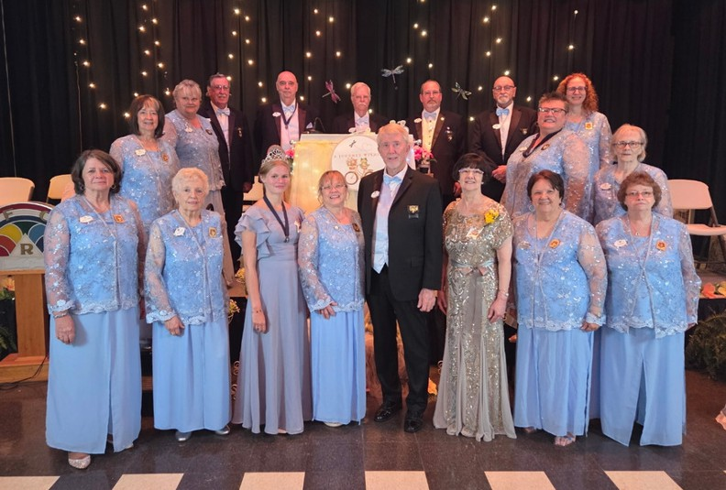

Grand Assembly

Grand Representative Club June Meeting
The Grand Representative Club held its June meeting with a luncheon on Sunday during our “United in Love and Harmony” Grand Chapter Session. We had 144 present including Sister Glenda Winchester, PMWGM and Sister Billie Bradfield, MWGM. It was nice to see all the different ideas for “On the Road Again” Themed Luncheon for the table hosts to come up with.
Honorary Club Memberships were presented to visiting Grand Representatives of other Jurisdictions to South Carolina as well as Grand Representatives of other Jurisdictions to Other Jurisdictions. There were seventeen that were recognized and presented with a club pin and certificate. They came from as far as California who brought her sweet family and stay over to visit Charleston while in the State, someone from Canada, and our favorite Scotsman, Brother Robert McKee, PGP of Scotland.
Entertainment was featured by Sister Lynette Jenkins and her rendition of the song “On the Road Again.” It featured her cardboard car that she drove around the banquet room and picked up The Jackson Grand Family as well as Sister Glenda and Sister Billie. It was a fun time to be had by all.
We invite all current and past Grand Representatives to our next meeting which will be Sunday, August 9, 2026, at 3 p.m., at The Lizard’s Thicket on Lexington Hwy in Columbia. We will be holding our election of Club Officers at this meeting. Guests are always welcomed.
Respectfully submitted, Sister Dawn Blizard, PM, Club PSN Reporter
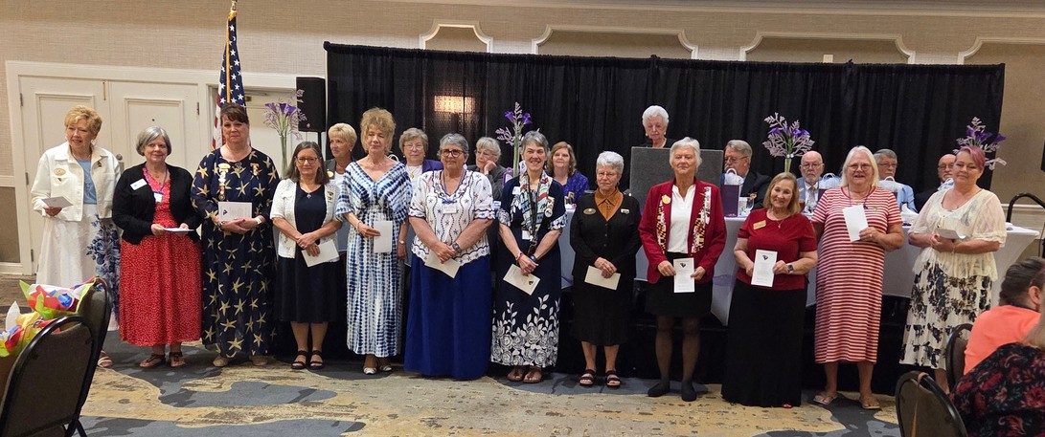

Palmetto Star News Update
Palmetto Star News
2050 Old Cherokee Road
Lexington, SC 29072
BULK MAIL
US POSTAGE
PAID
PERMIT NO. 595
COLUMBIA, SC
During the 2025-2026 Grand Chapter business session, a vote was taken regarding the printing of the Palmetto Star News (PSN). Due to increasing printing and postage costs, along with the declining number of subscribers, it was decided that the PSN would be an online only publication.
The PSN will be emailed to current subscribers and to the Grand Secretary who will send it out to all Chapter Secretaries to disseminate to their members. The PSN also will be posted to the scoes.org website for anyone that visits the website to view. There will be not be a subscription cost going forward.
Please continue to send in chapter and club articles, as well as photos. There will be no cost for anything related to the monthly PSN. The Souvenir Issue will still be printed and available for purchase at Grand Chapter as this is its only revenue generator now.



